ARBURG at Plastimagen 2026
Focus on new electric standard machines Allrounder Trend

- New: Two electric Allrounder Trend machines show potential across a wide range of applications
- New control system: Gestica lite makes machine operation quick and easy
- Digitalisation: Arburg MES and customer portal for process transparency and real-time monitoring

Lossburg, 14/09/2026
From 10 to 13 November 2026, Arburg will be exhibiting at Plastimagen in Mexico City, a trade fair of great significance for the plastics industry in Latin America. The focus of presence at Stand 830 will be on Arburg’s new electric Allrounder Trend machines. Two automated exhibits will demonstrate their wide range of applications. In addition, connected production will be showcased using Arburg’s digital solutions. These include the company’s own Manufacturing Execution System (ALS), the arburgXworld customer portal and Arburg Remote Service (ARS).

Julio Lopez, who took over as Managing Director of Arburg, S.A. de C.V. in Querétaro in July 2026, explains: “Plastimagen in Mexico an excellent opportunity to showcase our injection moulding technology in a clear and accessible way, to engage directly with customers and to demonstrate how our solutions can enable them to achieve their goals of repetition accuracy, reliability, precision and sustainability. The presentation of the Arburg product portfolio underlines our commitment to meet the requirements of markets, mobility, healthcare, electronics and leisure to name just a few examples, while also strengthening our position as a trusted technology partner”.

Two new Allrounder Trend machines show their potential
The two automated exhibits demonstrate an energy-efficient and cost-effective way of producing plastic parts, combined with a compact footprint and a high degree of flexibility.
An electric Allrounder 1000 e Trend with a clamping force of 1,000 kN produces PP keychains as example of high-volume parts using an 8-cavity mould. Handling is performed by a Multilift Select 8 linear robotic system.
The second Allrounder 1800 e Trend with a clamping force of 1,800 kN is also automated with a Multilift Select 8. Equipped with a 6-fold mould, this exhibit produces two safety glasses made of transparent PC at a time. Thanks to precise injection profile control, seamless part assembly is achieved while also ensuring consistent quality.

A perfect match: Allrounder Trend and Gestica lite
The Allrounder Trend machines are versatile, capable of satisfying a wide range of clamping force requirements. It can also support the advanced engineering demands and auxiliary equipment associated with larger moulds by its generous mould height and versatile design. These machines are suitable for general purpose applications across all industries and are available for delivery worldwide at short notice. Operators of all experience levels can set up the machines very rapidly. Allrounder Trend machines are intuitive to operate and easy to maintain, and they offer the advantage of high energy-saving performance combined with low investment and operating costs. Furthermore, they offer Arburg’s proven quality, complemented by a strong service presence in Mexico.
There are currently four machine sizes available, with clamping forces ranging from 500 to 2,000 kN. All Trend machines are equipped with the new Gestica lite control system that is designed to support both novice as well as experienced operators. This system features an intuitive user interface and a clearly laid out dashboard.
For automated injection moulding production, the Allrounder Trend can be equipped with all Arburg robotic systems and the appropriate compact protective guards. These are fully integrated into the machine controller and incorporated into customised turnkey systems.

Comprehensive digital products and services
A second focus at Plastimagen 2026 is the important topic of digitalisation, an area in which Arburg is a leader in the industry. Arburg’s own MES (ALS) supports users to maximise machine availability and production capacity, to reduce scrap rates and to deliver transparency to injection moulding production. Using the arburgXworld customer portal apps, users can, for example, configure Allrounder machines with the aid of AI. They can also retrieve information about machines or order spare parts right around the clock. In turn, Arburg Remote Service (ARS) enables customers to analyse machine conditions via remote diagnosis in collaboration with Arburg experts via a secure and encrypted data connection.

Arburg: More than a machine
Julio Lopez describes Arburg’s approach as a provider of complete solutions in the following terms: “Drawing on our in-depth experience, we offer far more than just machines. Instead, we support our customers to increase profitability throughout the entire project lifecycle with innovative, reliable and sustainable technology, extensive application expertise, tailored solutions, and comprehensive local and global sales and service support. Our turnkey experts can integrate injection moulding machines into high-performance automation and production environments. Our strong team at Arburg Mexico offers everything from a single source: Expert advice, Application Technology support, training and customer service. This ensures that our customers receive optimum levels of support before, during and after the implementation of their injection moulding systems”.

Images

ALLROUNDER 1000e TREND 290e_003

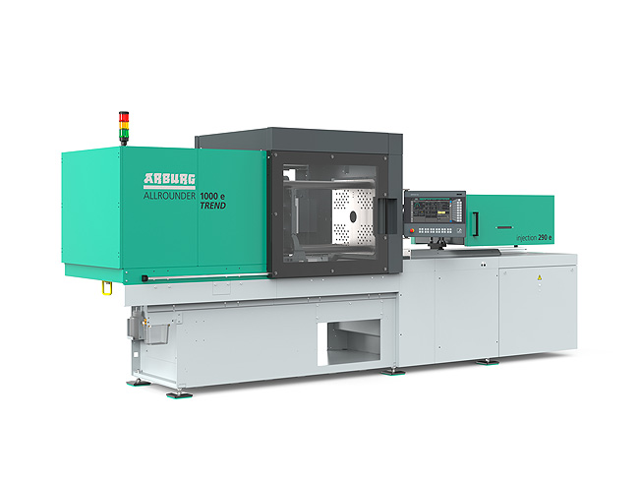

The new Allrounder Trend machines are specifically configured to meet current market needs: They are available at short notice, can be set up quickly, are particularly easy to operate and maintain, and are characterised by high energy efficiency as well as by low investment and operating costs.

Julio Lopez

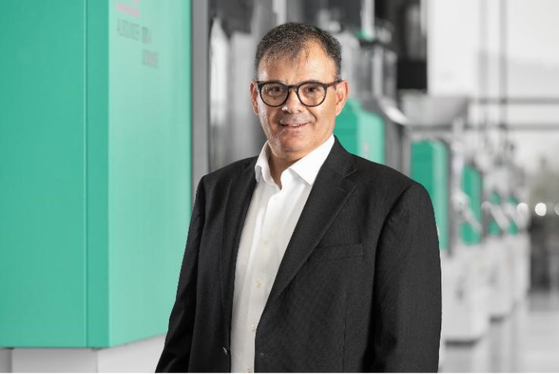

Julio Lopez has been the new Managing Director of Arburg’s subsidiary in Mexico since 21 July 2026.

Photos: ARBURG

Photo download:
https://media.arburg.com/web/bfcb9d16467dac94/plastimagen-2026-press-preview/

Press release
File: Press preview Plastimagen 2026_en_GB.docx
Characters: 5,078
Words: 748

This and other press releases are available for download from our website at www.arburg.com/de/presse/ (www.arburg.com/en/press/)

Contact
ARBURG GmbH + Co KG
Press office
Susanne Palm
Dr Bettina Keck
Postfach 1109
72286 Lossburg, Germany
Tel.: +49 (0)7446 33-3463
Tel.: +49 (0)7446 33-3259
presse_service@arburg.com

About Arburg
Founded in 1923, the German family-owned company is one of the world's leading manufacturers of injection moulding machines. AMKmotion, a manufacturer of electric drive technology, also belongs to the Arburg family.
The portfolio for plastics processing encompasses Allrounder injection moulding machines, robot systems as well as customer- and industry-specific turnkey solutions. It also includes digital products and services. Arburg is a pioneer in the plastics industry when it comes to energy and production efficiency, digitalisation and sustainability. Arburg machines are used to manufacture plastic products for the mobility, packaging, electronics, medical, construction and equipment engineering and leisure industries, for example.
The company headquarters are located in Lossburg, Germany. In addition, Arburg has own organisations in 27 countries at 37 locations and is represented in over 100 countries together with trading partners. Of a total of roughly 3,400 employees, about 2,800 work in Germany, with another 600 employees based in Arburg's organisations around the world.
Arburg is certified to ISO 9001 (Quality), ISO 14001 (Environment), ISO 27001 (Information Security), ISO 29993 (Education and Training) and ISO 50001 (Energy).
Further information: www.arburg.com, www.amk-motion.com.

