Arburg at TaipeiPlas 2026
Allrounder Trend makes its debut in Taiwan

- Highlight: In Taiwan the new electric Allrounder Trend standard machine is getting exhibited for the first time
- Attractive: Cost-effective, quick to get started, easy for operation and maintenance
- Comprehensive: Arburg Taiwan offers complete solutions tailored to customer requirements

Lossburg, 22/07/2026
TaipeiPlas 2026 will be held from 15 to 19 September at the Nangang Exhibition Centre in Taipei City. Arburg (TaiNEX1 1F, Stand K0727) will be showcasing its new Allrounder Trend electric standard machines in Taiwan for the first time. On display will be an automated exhibit producing the innovative ‘Donut-ella’ – a three-part USB cable winder.

“The new Allrounder Trend machines, equipped with the Gestica lite control system, enable a quick start to the injection moulding of standard components. They are cost-effective, available at short notice, particularly easy to operate and can be automated with robotic systems such as the Flexlift”, emphasises Mitchell Yang, Managing Director of Arburg Taiwan in Taichung. “With the innovative ‘Donut-ella’ application, we are showcasing our comprehensive expertise as a provider of complete solutions and demonstrating how our machine technology enables consistent quality to be achieved in the efficient production of high-quality plastic parts”.

Allrounder Trend: A new standard in injection moulding
The Allrounder Trend machines are suitable for standard applications across all industries and are available for immediate delivery worldwide. They impress with their low capital and running costs, as well as their ease of maintenance. This equips them to deliver a combination of high cost-efficiency combined with proven Arburg quality and a globally standardised level of service. All Trend machines are equipped with the new Gestica lite control system. This features an intuitive user interface and a clearly laid-out dashboard. There are currently four machine sizes available, with clamping forces ranging from 500 to 2,000 kN and injection speeds of 200 to 500 millimetres per second.

Innovative “Donut-ella” product
The exhibit, an Allrounder 1000 e Trend with a clamping force of 1,000 kN, produces the ‘Donut-ella’, which is shaped like a doughnut. This innovative product was developed by students. It won the ‘Pleiades’ design competition (Plastic European Innovation Award for Design and Sustainability) organised by the Italian IUAV University of Venice in December 2025. Arburg then rolled out this innovative application in collaboration with its partners Uniform (1+1+1-cavity family mould) and Ewikon (hot runner), which is being showcased at trade fairs around the world. At TaipeiPlas 2026, handling will be performed by a vertically entering Flexlift. This robotic system is optimally tailored to the requirements of customers in Asia and is only available there.

MES and customer portal actively support operators
Visitors to the Arburg stand can also gain a comprehensive overview of what ‘digitalisation’ means in practice. Among other things, Arburg’s own Manufacturing Execution System (the ALS) and the arburgXworld customer portal will be showcased. The Arburg MES helps to increase machine availability, reduce scrap rates and improve production efficiency and part quality. Using the tools integrated into arburgXworld, users can, for example, configure Allrounder machines, retrieve information about machines or order spare parts around the clock. In addition, the control systems’ assistance and pilot functions will be presented. These actively support the operator in day-to-day injection moulding operations.

„Wir sind da.“ – Arburg subsidiary in Taiwan
Arburg is a long-term partner and manufacturer of bespoke, complete solutions for plastics processing, which extend far beyond mere machine technology. In 2016, a subsidiary was established in Taichung, which features a showroom showcasing state-of-the-art Allrounders and robotic systems, and offers customers in Taiwan a wealth of expertise as well as a comprehensive portfolio of technology and service solutions. In line with its brand promise, “Wir sind da.”, Arburg Taiwan places great emphasis on customer proximity. This includes advice on application technology, automation and digitalisation, as well as comprehensive pre-sales and after-sales support.
At TaipeiPlas, Arburg’s experts will also be providing in-depth information on how to achieve smart, efficient and sustainable plastic parts production, with the benefits of reduced total cost of ownership (TCO) and enhanced part quality.

Images

ALLROUNDER 1000e TREND 290e

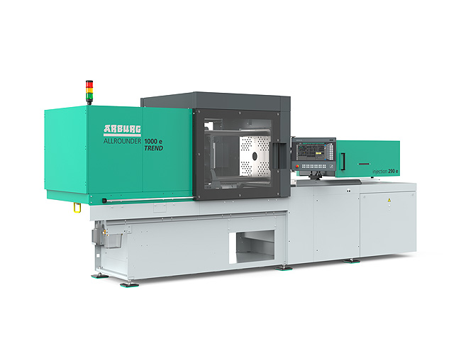

The new Allrounder Trend machines are specifically configured to meet current market needs: They can be set up quickly, are particularly easy to set-up. operate and maintain and are characterised by low investment and running costs.

ALLROUNDER 1800 e TREND_397

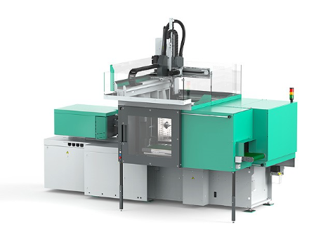

The new Allrounder Trend standard machines can be fitted with all Arburg robotic systems.

Photos: ARBURG
Photo download:
https://media.arburg.com/web/c36041253c707c04/allrounder-trend-2026-article/

Press release
File: TaipeiPlas 2026 press preview_en.docx
Characters: 4.326
Words: 620

You can also download this and other press releases from our website at www.arburg.com/de/presse/ (www.arburg.com/en/presse/)

Contact
ARBURG GmbH + Co KG
Press Office
Susanne Palm
Dr Bettina Keck
PO Box 1109
72286 Lossburg, Germany
Tel.: +49 7446 33-3463
Tel.: +49 7446 33-3259
presse_service@ARBURG.com

About ARBURG
Founded in 1923, this German family-owned company is one of the world’s leading manufacturers of injection moulding machines. The ARBURG family also includes AMKmotion, a manufacturer of electric drive systems.
Arburg’s portfolio for plastics processing comprises ALLROUNDER injection moulding machines, robotic systems and customer- and industry-specific turnkey solutions. It also includes digital products and services. Within the plastics industry, Arburg is a pioneer in the areas of energy and production efficiency, digitalisation and sustainability. Arburg machines are used to manufacture plastic products for industries such as Mobility, Packaging, Electronics, Medical, Construction and equipment engineering, as well as Leisure.
The company’s headquarters are in Lossburg, Germany. Furthermore, ARBURG has its own organisations in 27 countries at 37 locations and, together with its distribution partners, has representation in over 100 countries. Of the total workforce of around 3,450 employees, approximately 2,850 are based in Germany and around 600 work in ARBURG’s organisations worldwide.
ARBURG is certified to ISO 9001 (quality), ISO 14001 (environment), ISO 27001 (information security), ISO 29993 (training) and ISO 50001 (energy).
Further information: www.arburg.com, www.amk-motion.com.

