Arburg at Vietnamplas 2026
Allrounder Trend presented in Vietnam for the first time

- Highlight: New electric Allrounder Trend standard machine
- Attractive: Cost-effective, fast entry, simple operation and easy maintenance
- Comprensive: Complete solutions tailored to customer requirements

Lossburg, 20/07/2026
Vietnamplas 2026 will take place in Ho Chi Minh City from 9 to 12 September. Arburg will be presenting its new electric standard machines in Vietnam for the first time at its stand 219 in Hall B. On display will be an Allrounder 1800 e Trend, which produces silicone tube nozzles as an example.

“Vietnam is a rapidly growing plastics market in the ASEAN region and is becoming increasingly attractive for the manufacture of electronics, medical devices, packaging and consumer goods,” says David Chan, Managing Director of Arburg in the ASEAN region. “We are ideally positioned in the standard segment with our new electric Allrounder Trend machines. Furthermore, we are showcasing our comprehensive range of digital products and services.”

Allrounder Trend: New standard in injection moulding
The Allrounder Trend machines are suitable for standard applications across all industries and are available worldwide at short notice. They can be set up particularly quickly, are intuitive to operate and easy to maintain, and impress with their high energy efficiency and low investment and operating costs. They also offer proven Arburg quality and a globally standardised service.
The new machines are available in four sizes with clamping forces ranging from 500 to 2,000 kN. All Trend machines are equipped with the new Gestica lite control system, which features an intuitive user interface and a clearly laid-out dashboard.
At Vietnamplas 2026, an Allrounder 1800 e Trend with an 16-cavity mould will be on display, processing the robust thermoplastic material HDPE into nozzles for silicone tubes. Sixteen injection-moulded parts are produced free-falling in a cycle time of around 9.5 seconds.

Arburg subsidiary in Vietnam
Arburg has had its own subsidiary in Ho Chi Minh City, Vietnam, since the year 2023, enabling it to support customers in this important market directly on the ground. In this way, the company ensures that specialists are on hand quickly, reliably and comprehensively – in keeping with Arburg’s brand promise: “Wir sind da.”
Aburg is a partner that offers its customers tailor-made, complete solutions that go far beyond mere machine technology. These include automation and peripheral equipment as well as comprehensive pre- and after-sales support. The topic of digitalisation is also becoming increasingly important. Trade fair visitors can gain an overview of digital features and innovations, for example Arburg’s own MES (ALS) and the arburgXworld customer portal. Experts will explain how smart, efficient and sustainable plastic parts production can be achieved, with the benefits of reduced total cost of ownership (TCO) and improved part quality.

Images

ALLROUNDER 1000e TREND 290e

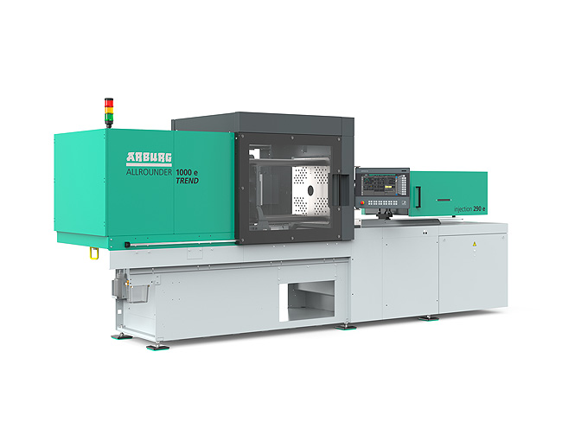

The new electric standard machines Allrounder Trend are specifically designed to meet current market needs: they are available at short notice, can be set up quickly, are particularly easy to operate and maintain, and are characterised by low investment and operating costs.

ALLROUNDER 1800 e TREND_397

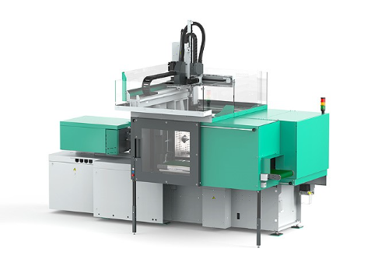

If required, the Allrounder Trend machines can be equipped with Arburg robotic systems.

Photos: ARBURG
Photo download:
https://media.arburg.com/web/c36041253c707c04/allrounder-trend-2026-article/

Press release
File: Vietnamplas 2026 press release_en.docx
Characters: 2,674
Words: 414

You can also download this and other press releases from our website at www.arburg.com/de/presse/ (www.arburg.com/en/presse/)

Contact
ARBURG GmbH + Co KG
Press Office
Susanne Palm
Dr Bettina Keck
PO Box 1109
72286 Lossburg, Germany
Tel.: +49 7446 33-3463
Tel.: +49 7446 33-3259
presse_service@ARBURG.com

About ARBURG
Founded in 1923, this German family-owned company is one of the world’s leading manufacturers of injection moulding machines. The ARBURG family also includes AMKmotion, a manufacturer of electric drive systems.
ARBURG’s portfolio for plastics processing comprises Allrounder injection moulding machines, robotic systems and customer- and industry-specific turnkey solutions. It also includes digital products and services. Within the plastics industry, Arburg is a pioneer in the areas of energy and production efficiency, digitalisation and sustainability. Arburg machines are used to manufacture plastic products for industries such as Mobility, Packaging, Electronics, Medical, Construction and equipment engineering, as well as Leisure.
The company’s headquarters are in Lossburg, Germany. Furthermore, ARBURG has its own organisations in 27 countries at 37 locations and, together with its distribution partners, has a representation in over 100 countries. Of the total workforce of around 3,450 employees, approximately 2,850 are based in Germany and around 600 work in ARBURG’s organisations worldwide.
ARBURG is certified to ISO 9001 (quality), ISO 14001 (environment), ISO 27001 (information security), ISO 29993 (training) and ISO 50001 (energy).
Further information: www.arburg.com, www.amk-motion.com.

