Arburg to remain sponsor of the DTM in 2026
Successful premium partnership with ABT enters its second year

- Win-win situation: Arburg and ABT Sportsline – tech beacons in their respective industries
- Sponsorship: Leveraging the wide reach of sport
- Mobility: Increasing the company's visibility in key markets

Lossburg, 04/03/2026
Based on its very encouraging track record, Arburg will be continuing its motorsport sponsorship in 2026. In one of the best-known international racing series, the German Touring Car Masters (DTM), the globally active machine manufacturer is once again partnering with ABT Sportsline, the most successful active DTM racing team.

ADAC (General German Automobile Club) has been organising the German Touring Car Masters ever since 2021, an event that features thrilling races at the highest level, live on TV and online. In contrast to endurance races, the DTM focuses on high-speed races without driver changes.

Emotions, fascination with technology, top performance
For many years, Arburg has been using sports sponsorship to position and promote the brand in the best possible way, creating business networks and exciting moments for customers while also further expanding the perception of Arburg and its values as a top brand in the desired target groups. The huge response to the DTM contributes to this: an enormous gain for Arburg, further enhanced by the many emotions that this racing series triggers year after year, not only in the racing community but also in large parts of the sports-loving society. All of which explains why the company made a conscious decision to support the DTM and to sponsor ABT Sportsline.

Commitment pays off
Managing Partner Juliane Hehl comments on Arburg’s involvement: “We do not view our commitment to the DTM as an end in itself, nor simply because this is a huge spectacle with glamour appeal. For a machine manufacturer like Arburg, the DTM is extremely close to the interests of many of our customers and their employees. The points of contact for the Arburg brand are compelling. These range from the ultimate technological precision that determines victory or defeat, to the sound teamwork required to achieve innovation and peak performance on a daily basis and also extends to the people whose shared spirit of endeavour make such powerful, sometimes even radically disruptive solutions possible. This set of attributes is shared by Arburg and ABT alike. Which is why this sponsorship is exactly the right way for us to convey and emphasise the fundamental elements of our brand”.

Managing Partner Michael Hehl adds: “We share common values with this racing series and with our partner ABT. Our wish is to build trust in technology, not least at an emotional level, thereby making a powerful statement for our technology-led industry. Another exciting aspect is the business networking to which this environment lends itself so well. This is a very important platform, of great benefit to the development of our business. In 2025, our first year here, the opportunities that this sponsorship offers became very clear to us. This year, we aim to continue leveraging this commitment for our company and to expand it successfully”.

ABT: Long with Audi, now with Lamborghini
Last season marked the beginning of a new era for ABT Sportsline in the DTM: after 25 years with Audi, the DTM team started with vehicles from the iconic Italian brand Lamborghini for the first time, coinciding with the start of Arburg’s sponsorship.
Last year marked exactly 75 years since Johann Abt competed in his first motor race. Almost 100 racing drivers have competed under this name during this time. This has resulted in a total of ten championship titles and 78 race victories for ABT Sportsline alone in the DTM. In addition, there have been 259 podium finishes, 92 pole positions and 85 fastest race laps. In addition to several generations of Abts, DTM fans will also remember illustrious racing drivers such as Laurent Aiello, Mattias Ekström and Timo Scheider. Mirko Bortolotti and Nicki Thiim formed the ABT Sportsline driver team in 2025.

The fact that the cooperation between ABT and Arburg is a win-win situation is demonstrated not least by other well-known, globally active sponsors who have chosen the ABT Racing Team. In 2025, these included Red Bull (energy drinks), Sonax (car care), Schaeffler (drive technology) and MAN (trucks and buses), as well as Ravenol (lubricants) as technical partners. Some of these premium brands are also part of Arburg’s customer or supplier environment.

Sponsorship with maximum reach
Some impressive figures demonstrate the reach of the DTM: In 2025, the races were broadcast live and relayed to 185 countries around the world, reaching more than 500 million viewers. Around 1,100 reports had already been published in the German print media alone after four races at the halfway point of the racing series. 8,752 social media posts were available to 694.5 million DTM enthusiasts around the globe. The joint DTM team presentation by ABT Sportsline and Red Bull in the Alps went viral immediately after its release in February 2025, reaching over a million views on Instagram alone in less than ten hours. In the days that followed, this figure more than doubled. With 516,500 spectators at eight events throughout the season, the DTM Check 2025 saw a significant increase in attendance at all tracks.

Photos

DTM Sponsoring 19022025_J0A1824
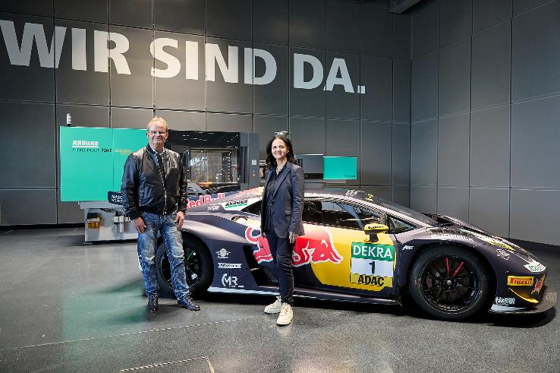

The ABT partner meeting took place on 19 February 2025 at the headquarters of sponsor Arburg in Lossburg. The two Managing Partners, Juliane and Michael Hehl, in front of the ABT Lamborghini Huracán GT3 EVO2.

Photo: ARBURG

Mirko Bortolotti.jpg 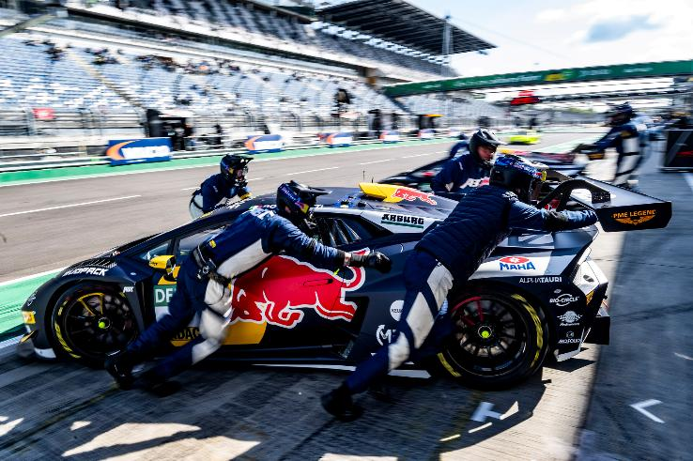

Pit stop: The ABT Lamborghini Huracán GT3 EVO2 in race trim during the third and fourth DTM races at the Lausitzring in 2025.

Photo: ABT Sportsline

Arburg, H&R, Red Bull.jpg

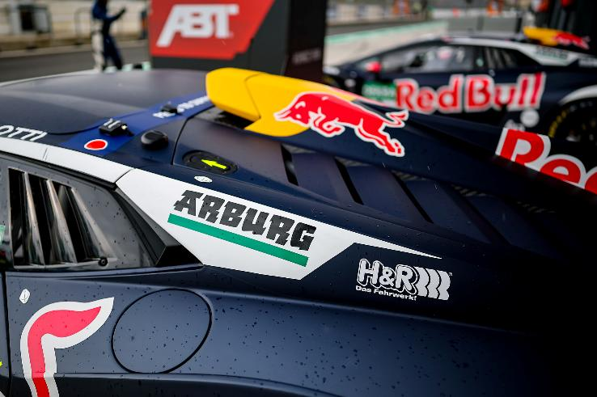

In good company: Sponsors Arburg, H&R and Red Bull with their logos on Mirko Bortolotti's DTM race car during the fifth and sixth races at Zandvoort in 2025.

Photo: ABT Sportsline

Photo download:
https://media.arburg.com/web/f665d8f7ac4acc2b/dtm-sponsoring-arburg-abt/

Press release
File: Pressemitteilung ABT Sponsoring DTM 2026_en_GB.docx
Characters: 5,076
Words: 827

This and other press releases are also available for download on our website at www.arburg.com/de/presse/ (www.arburg.com/en/presse/).

Contact
ARBURG GmbH + Co KG
Press office
Susanne Palm
Dr Bettina Keck
Postfach 1109
72286 Lossburg, Germany
Tel.: +49 (0)7446 33-3463
Tel.: +49 (0)7446 33-3259
presse_service@arburg.com

About Arburg
Founded in 1923, the German family-owned company is one of the world's leading manufacturers of injection moulding machines. AMKmotion, a manufacturer of electric drive technology, also belongs to the Arburg family.
The portfolio for plastics processing encompasses Allrounder injection moulding machines, robot systems as well as customer- and industry-specific turnkey solutions. It also includes digital products and services. Arburg is a pioneer in the plastics industry when it comes to energy and production efficiency, digitalisation and sustainability. Arburg machines are used to manufacture plastic products for the mobility, packaging, electronics, medical, construction and equipment engineering and leisure industries, for example.
The company headquarters are located in Lossburg, Germany. In addition, Arburg has own organisations in 27 countries at 37 locations and is represented in over 100 countries together with trading partners. Of a total of roughly 3,400 employees, about 2,800 work in Germany, with another 600 employees based in Arburg's organisations around the world.
Arburg is certified to ISO 9001 (Quality), ISO 14001 (Environment), ISO 27001 (Information Security), ISO 29993 (Education and Training) and ISO 50001 (Energy).
Further information: www.arburg.com, www.amk-motion.com.

