Arburg at Fakuma 2026
NextGen Medical Solution: Groundbreaking production cell optimised with AI tools

- Targeted and efficient: Customer benefits through early collaboration between project partners
- Expanded: Benchmark cell utilises AI tools to optimise process and product quality
- Injector pen caps: Quick path to a ready-to-use product whilst reducing TCO and running costs

Lossburg, 24/09/2026
At Fakuma 2026, Arburg (Hall A3, Stand 3101) will be presenting the expanded ‘NextGen Medical Solution’ project. To set a benchmark in medical technology, Arburg (machinery), Hack Formenbau (mould engineering), HB-Therm (temperature control units) and a leading biopharmaceutical OEM have taken a holistic view of the potential for optimisation and have completed that journey together. In this turnkey system, centred around an electric Allrounder 570 A, the machine, mould, automation and peripherals are digitally networked. A new feature is the ‘Hopper’ from Plus10, integrated into the Gestica control system. This AI tool uses machine learning to optimise parameters and product quality.

The example of caps for injector pens illustrates the enormous advantages offered by the manufacturing cell. Firstly, collaboration from an early stage between all key partners in the implementation of such sophisticated production cells reduces the burden for the OEM or the customer respectively. Secondly, the total cost of ownership (TCO) is reduced through the precise coordination and integration of all essential peripheral devices into the central Gestica machine control system. Int urn, this makes the production cell reliable and simple to operate. Further customer benefits range from a short time-to-market and rapid time-to-production, achieved through minimised running costs for energy and floor space, to reduced costs for quality inspection. As the main contractor, Arburg bears overall responsibility for the production cell, including both hardware and software.

Data consolidated in central Gestica control system
The focus of the ‘NextGen Medical Solution’ production cell, centred around an electric Allrounder 570 A in a cleanroom version, is on Parametric Release, i.e. it holds approval for the medical and pharmaceutical industries. At the heart of the exhibit is an 8-cavity mould from Hack. This processes PP from Borouge International into caps for injector pens in a cycle time of around ten seconds. A suspended, space-saving six-axis robot – integrated into the control system – removes the moulded parts from the mould and places them in separate locations according to cavity. A major benefit is the shared data set in Gestica. This consolidates the mould data as well as data from temperature control units and the robot system. This makes the production cell easier to control, quicker to bring into production. It also results in less scrap.
All data is logged centrally – not only in the control system, but also in the digitally networked customer portal arburgXworld and Arburg’s own MES (ALS). This enables clear shot allocation.

New: Integrated AI tool ‘Hopper’
In addition, Plus10’s ‘Hopper’ has now been integrated into the Gestica control system. This software tool uses artificial intelligence (AI) to analyse machine and process data in real time, automatically detect deviating patterns. This tool also learns correlations between process parameters and quality and makes predictions in relation to part quality. In the event of relevant deviations, ‘Hopper’ suggests optimised process parameters that can be applied immediately. This reduces the need for time-consuming quality checks. Furthermore, key quality parameters can be viewed at any time and documented directly within the control system. This system will be getting demonstrated live at Fakuma 2026.

Smart communication between mould and machine
The ‘aXw Control MoldlifeAssist’ – the ‘Moldlife Sense’ computer system from partner Hack Digital Solutions, which is fully integrated into the Gestica control system – is especially well-suited to complex moulds and high-volume production runs. This enables smart communication between the machine or production cell and the injection mould, based on the Euromap 82.5 interface. The associated hardware consists of a connector on the fixed mould base and a box at the rear of the machine. This enables a single system to be used for multiple moulds.
‘MoldlifeAssist’ supports the set-up, monitoring and maintenance of the mould, improving availability and operator safety. Its ’Set-up Assistant’ with digital alignment aid guides the operator step by step using images. Using integrated sensor technology, the mould is monitored throughout its entire life cycle regarding temperature, acoustics, breathing and alignment (condition monitoring). The readings from various sensors can be displayed and monitored in the control system, while also enabling mould data to be logged and documented.

Part quality defined, documented and ensured
Further defined interfaces, as well as assistance and pilot functions, help to speed up processes, to reduce errors, to improve part quality and to achieve a fast time-to-market. By way of example, the ‘aXw Control FillAssist’ ensures rapid process optimisation, while the new ‘aXw Control DoEAssist’ enables the correct process window to be determined quickly. It also provides structured validation in the form of ‘Design of Experiments’ (DoE) directly to the machine. Other assistants enable a wide process window and high efficiency. These include features such as the ‘aXw Control MeltAssist’. It ensures optimised utilisation of the plasticising unit and dwell times. The ‘aXw Control CycleAssist’, eliminates non-productive times during the cycle, and the ‘aXw Control EnergyAssist’ for energy-efficient heating and shutdown of the cylinder module. The tolerance limits for the process window can be defined within the program. The ‘aXw Control StabilityAssist’, in turn, enhances process stability by continuously monitoring key parameters and by detecting gradual deviations. Through integrated maintenance management, extensive use of sensor technology and predictive maintenance, maintenance effort and unscheduled downtime can be reduced significantly.

Images

Allrounder 570A NextGen_00006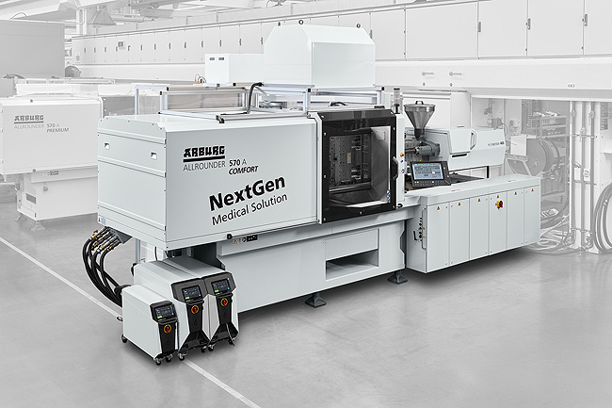
‘NextGen Medical Solution’: At Fakuma 2026, a turnkey system centred around an electric Allrounder 570 A will be producing caps for injector pens. Working in close collaboration, Arburg, Hack Formenbau, HB-Therm and a well-known OEM have taken a holistic view of the potential for optimisation.

570A NextGen Medical DE_DSC6411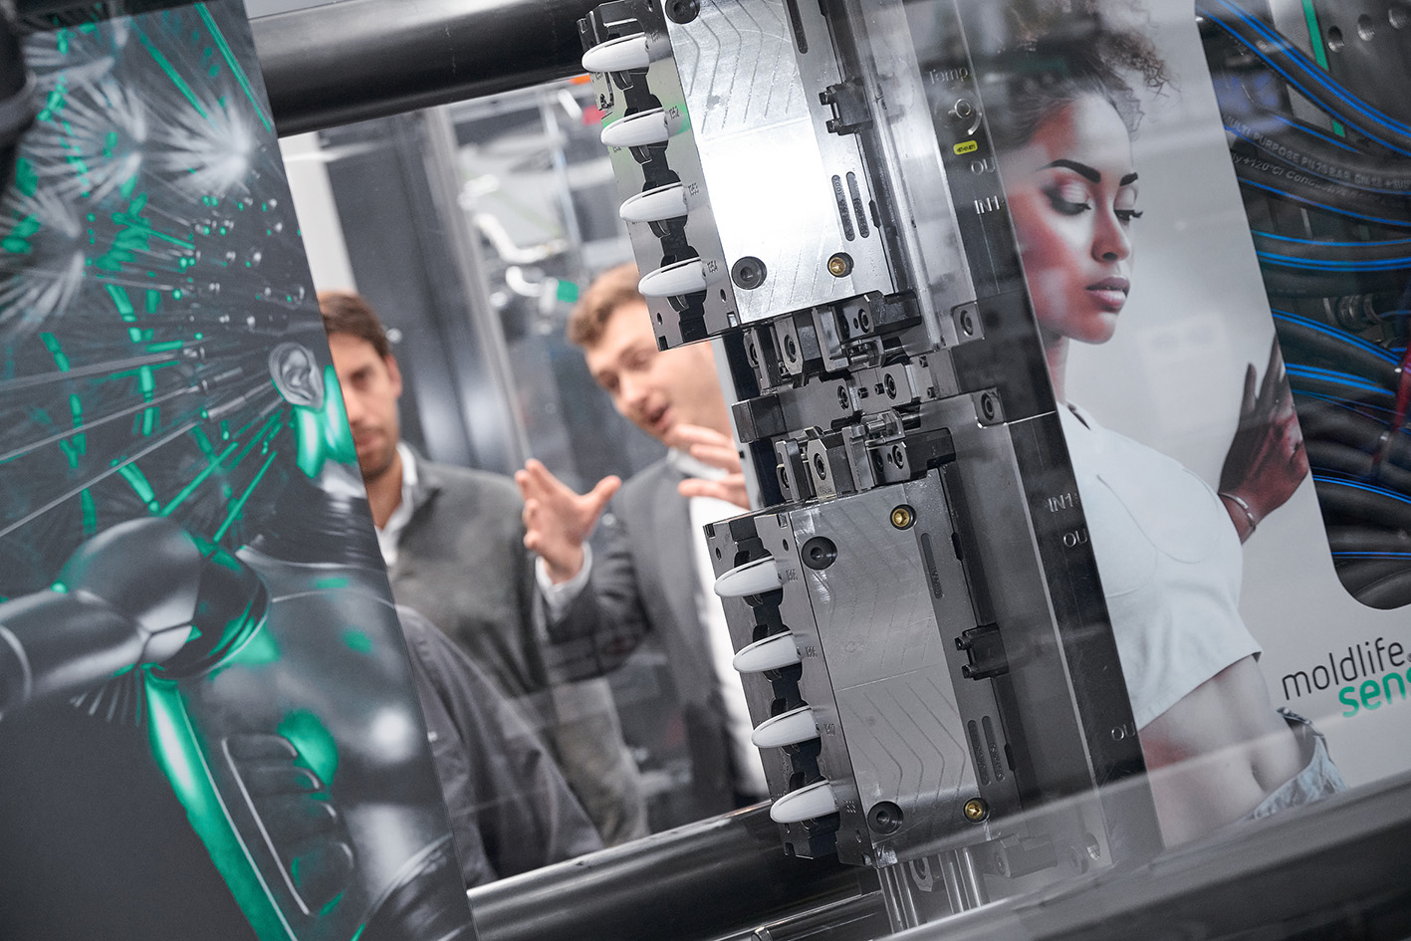
At Fakuma 2026, Arburg will use the example of caps for injection pens to demonstrate how medical products can be produced cost-effectively and to a high standard of part quality, accomplished with the help of digital networking and intelligent control functions.

570A GESTICA DE MoldlifeAssist_D1A0922
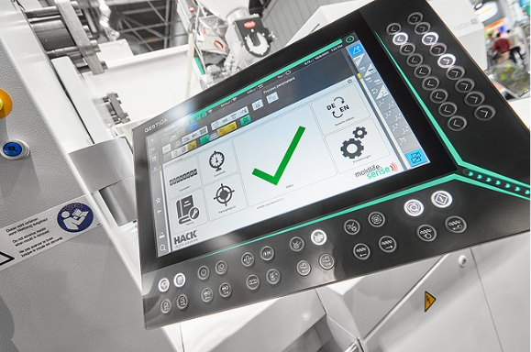
‘Smart’ communication between the machine and the injection mould is made possible by the ‘aXw Control MoldlifeAssist’, fully integrated into the Gestica control system.

Photos: Arburg

Photo download:
https://media.arburg.com/web/316e7a9063bf453c/570a-nextgen-medical-fakuma-2026/

Press release
File: ARBURG press release Allrounder 570A NextGen Fakuma 2026_en_GB.docx
Characters: 5,843
Words: 860

This and other press releases are available for download from our website at www.arburg.com/de/presse/ (www.arburg.com/en/press/)

Contact
ARBURG GmbH + Co KG
Press office
Susanne Palm
Dr Bettina Keck
Postfach 1109
72286 Lossburg, Germany
Tel.: +49 (0)7446 33-3463
Tel.: +49 (0)7446 33-3259
presse_service@arburg.com

About Arburg
Founded in 1923, this German family-owned company is one of the world’s leading manufacturers of injection moulding machines. The Arburg family also includes AMKmotion, a manufacturer of electric drive technology.
Arburg’s portfolio for plastics processing comprises Allrounder injection moulding machines, robotic systems and customer- and industry-specific turnkey solutions. It also includes digital products and services. In the plastics industry, Arburg is a pioneer in the areas of energy and production efficiency, digitalisation and sustainability. Arburg machines are used to manufacture plastic products for sectors such as mobility, packaging, electronics, medicine, construction and equipment manufacturing, as well as leisure.
The company’s headquarters are located in Lossburg, Germany. Furthermore, Arburg has its own organisations in 27 countries at 37 locations and is represented in over 100 countries through its distribution partners. Of the total workforce of around 3,400 employees, approximately 2,800 are based in Germany and around 600 in Arburg’s global organisations.
Arburg is certified to ISO 9001 (Quality), ISO 14001 (Environment), ISO 27001 (Information Security), ISO 29993 (Training) and ISO 50001 (Energy).
Further information: www.arburg.com, www.amk-motion.com.

