2026 apprenticeship cohort
44 new apprentices and DHBW students at Arburg

- Start of professional life: A total of 32 new apprentices and 12 DHBW students
- Managing Director Steffen Kroner: Shaping the future together
- Certified and award winning: More than 2,400 young professionals trained over more than 75 years

Lossburg, 02/09/2026
On 1 September 2026, 32 apprentices and 12 students from the Baden-Württemberg Cooperative State University (DHBW) began their careers at Arburg. Steffen Kroner, Managing Director Finance, Controlling, IT and Global HR at Arburg, as well as Michel Vieth, Director Apprenticeship, warmly welcomed the 44 new ‘family members’ to Lossburg before they embarked on an exciting induction week.

“For us, apprenticeships are a central building block for a successful future. Even in challenging economic times, there is no question that we will continue to provide apprenticeships,” emphasised Steffen Kroner in his welcome address to the 2026 intake of apprentices on behalf of the Arburg Partner families, the management team and the entire workforce. “Over the past 75 years, we have laid the foundations for more than 2,400 young people to start their professional careers at Arburg. We are delighted that the 2026 intake of apprentices will now also be joining us in shaping Arburg’s future as the solution partner for sustainable plastics processing together with us”.

A multi-faceted induction week
The 2,000-square-metre Vocational Training Center will in future serve as the central hub for the new apprentices and students. To help all the new recruits from this year’s intake as well as the trainers and other points of contact to get to know one another better, Michael Vieth and his team have organised a multi-faceted induction week. This begins with a guided tour of the premises, helping new arrivals to get their bearings and to discover and learn more about the product range and Arburg as a company.
There will also be an exciting outdoor team challenge at “Zauberland (land of magic)” in Lossburg, where the newcomers will be given the opportunity to demonstrate their skills, ingenuity and team spirit at six stations.

Teamwork on exciting projects
In addition to technical skills, interdisciplinary collaboration is encouraged as part of the training programme, especially within the wide-ranging context of project work. For example, apprentices have won the VDMA’s ‘Carbon Busters’ Award on several occasions. The VDMA, association for the machinery and equipment manufacturing industry in Europe and Germany, presents this award to young people in recognition of their commitment to tackling climate-related issues. In 2025, a team of apprentices took part in the CarbonX Week, sponsored by Arburg, during the Tal X Garden Show Freudenstadt Baiersbronn, Germany. In addition to this, apprentices and students manned the arburgGREENworld pavilion at the world’s leading trade fair, K 2025, in Düsseldorf.
For the ‘Mold your Future’ Career Friday at Fakuma plastics trade fair on 16 October 2026, over 60 apprentices and trainers will be joining the Arburg exhibition team in Friedrichshafen, Germany. Here, young people will be given guided tours of the stand, introducing them to Arburg’s digital portfolio and to the wide range of career opportunities available at the company.

Arburg’s award-winning apprenticeship programme
The family-run company based in Lossburg is currently training around 200 young people to become qualified personnel – one in four of whom is a DHBW student. Arburg works closely with vocational schools and cooperative universities and was the first company in Baden-Württemberg to achieve triple certification back in 2018, including certification by TÜV Nord to ISO 29993 for quality management in vocational training. In addition, it has received the LQW award (learner-oriented quality assessment in continuing education) and the seal of approval from the IHK, Germany’s Chamber of Industry and Commerce. Furthermore, Arburg is one of the largest training providers in the northern Black Forest and this year, it was promptly awarded the newly introduced ‘Sustainability Certification for Apprenticeships’. All of these certifications confirm the outstanding quality of Arburg’s comprehensive apprenticeship programme.

Apply now for 2027
Arburg consistently provides needs-based training – across more than 15 different professions. Around 50 places are available for 2027. There is a wide range of apprenticeship programmes and DHBW degree courses to choose from. The range covers commercial and technical professions, such as machining technician, product designer, plastic and rubber technologist, skilled personnel for warehouse logistics and IT specialists. The degree programmes include industrial engineering, computer science, mechatronics, electrical engineering and mechanical engineering.
Anyone interested in an apprenticeship or a DHBW degree programme at Arburg can find all the information they need about the roles and the application process on the apprentices’ website at www.ausbildung.arburg.com, or directly via the applicant portal at www.arburg.com/info/ausbildung.

Image

Arburg apprenticeship cohort 2026_M1A1228

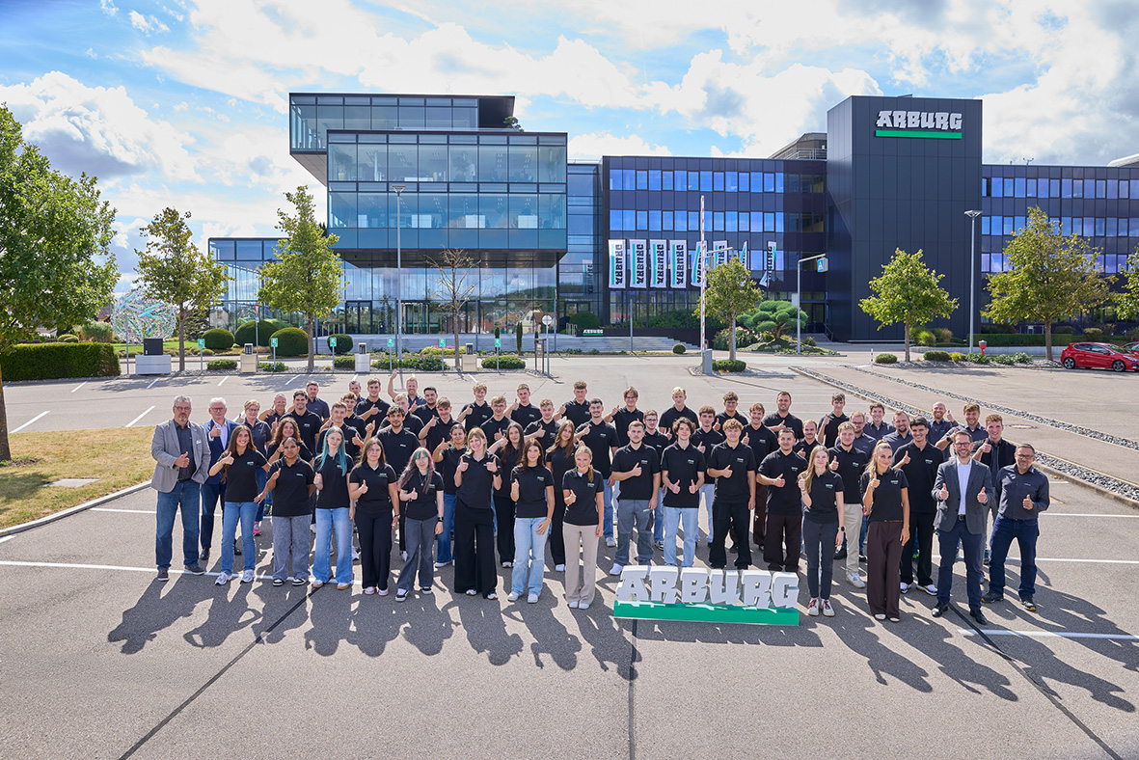

On 1 September 2026, 44 apprentices and DHBW students began their vocational training or DHBW degree programme at Arburg in Lossburg.

Photo: ARBURG

Photo download:
https://media.arburg.com/web/1cfa2b31eee47c8b/arburg-azubis-2026/

Press release
File: Pressemitteilung Ausbildungsjahrgang 2026_en_GB.docx
Characters: 4,826
Words: 718

This and other press releases are available for download from our website at www.arburg.com/de/presse/ (www.arburg.com/en/press/)

Contact
ARBURG GmbH + Co KG
Press office
Susanne Palm
Dr Bettina Keck
Postfach 1109
72286 Lossburg, Germany
Tel.: +49 (0)7446 33-3463
Tel.: +49 (0)7446 33-3259
presse_service@arburg.com

About Arburg
Founded in 1923, the German family-owned company is one of the world's leading manufacturers of injection moulding machines. AMKmotion, a manufacturer of electric drive technology, also belongs to the Arburg family.
The portfolio for plastics processing encompasses Allrounder injection moulding machines, robot systems as well as customer- and industry-specific turnkey solutions. It also includes digital products and services. Arburg is a pioneer in the plastics industry when it comes to energy and production efficiency, digitalisation and sustainability. Arburg machines are used to manufacture plastic products for the mobility, packaging, electronics, medical, construction and equipment engineering and leisure industries, for example.
The company headquarters are located in Lossburg, Germany. In addition, Arburg has own organisations in 27 countries at 37 locations and is represented in over 100 countries together with trading partners. Of a total of roughly 3,400 employees, about 2,800 work in Germany, with another 600 employees based in Arburg's organisations around the world.
Arburg is certified to ISO 9001 (Quality), ISO 14001 (Environment), ISO 27001 (Information Security), ISO 29993 (Education and Training) and ISO 50001 (Energy).
Further information: www.arburg.com, www.amk-motion.com.

