Network partnership in the packaging sector
Arburg becomes a partner of the Thin Wall Packaging Academy (TWPA)

- Forward-looking: educational initiative with Packaging experts
- Win-win situation: Partnership with learning platform
- International: Exchange on the thin-wall packaging market

Lossburg, 02/04/2026
13 March 2026 marked the final day of the Technology Days industry event at Arburg in Lossburg, Germany. It also marked he official launch of the network partnership with the Thin Wall Packaging Academy (TWPA) based in Au, Switzerland. This collaboration is intended to result in a win-win situation that raises awareness of thin-wall injection moulding not only within the industry but also among the general public. This is to be achieved through intensive training of specialists, who can then in turn present the positive benefits of thin-wall packaging, enhancing its public image.

The aim of the partnership is to facilitate the exchange of developments, ideas and requirements among the network partners regarding the manufacture and use of thin-wall packaging. Michael Haug from the Arburg Packaging Team comments: “The aim is to raise awareness of the topic, positively influence the reach of all partners with thin-wall experience, and draw more attention to the packaging sector within plastics processing through the formation of a cluster”.

Foundations laid at the world’s leading trade fair, K 2025
The network partnership with TWPA is “a voluntary, non-contractual association based on mutual respect and a shared commitment to modern, practice-oriented education in the field of ‘thin-walled packaging” (www.thinwallpackaging.com). Nijaz Husidic, business coach and TWPA lecturer, first became aware of Arburg during the world’s leading trade fair K 2025. There, at the Arburg stand, he noticed IML cups being produced by an electric Allrounder 720 A with a 4-cavity tool and fast-take-out automation from Brink. The size 1300 electric injection unit achieved injection speeds of up to 400 millimetres per second. With this exhibit, Arburg demonstrated that the injection compression moulding process represents an efficient alternative to thermoforming. Markus Haas from the Arburg Packaging Team describes the advantages of combining injection compression moulding and in-mould labelling (IML) as follows: “With this innovative process, we achieve a lighter component while also simultaneously optimising clamping force and energy requirements. These are tangible benefits that we wish to bring to the attention of specialists and, through them, to the wider public in partnership with TWPA. After all, injection compression moulding of thin-walled articles effectively minimises the use of plastics, particularly in serial production”.

Practical training and further education formats
The exchange on process technology and Arburg’s application expertise convinced the organisers of TWPA. They even designated the exhibit as a trade fair highlight and mentioned it in their follow-up report on K 2025. Through this partnership, the training institution can now also use the contents of Arburg presentations and practical expertise for its own events. This enables course participants to gain a broader understanding, and to do so from various perspectives. For example, on thin-wall packaging technology and injection compression moulding. The learning platform offers a total of four part-time online sessions:
- Introduction to thin-wall packaging
- Learning module on tools, process and product design in thin-wall packaging (TWP)
- Automation and IML in TWP
- Packaging technologies and processes

Photo

Packaging cooperation TWPA DE 2026 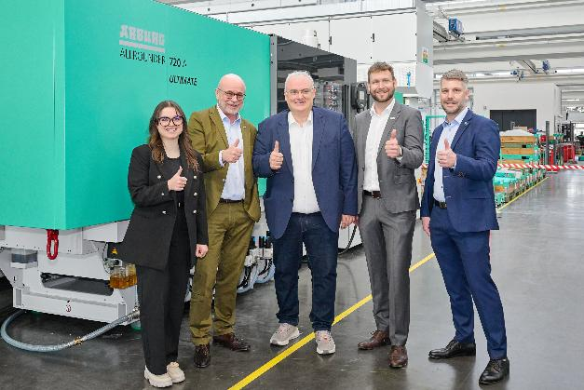

New network partners in front of an electric Allrounder 720 A producing thin-walled IML containers (from left): Katharina Schwab (International Marketing) and Dr Christoph Schumacher (Vice President Global Marketing) from Arburg with Nijaz Husidic from the Thin Wall Packaging Academy, as well as Michael Haug (Market Product Manager Medical & Packaging) and Markus Haas (Sales Manager Packaging) from the Arburg packaging team.

Photo: ARBURG
Photo download:
https://media.arburg.com/web/ec6902656fa7a6a7/Packaging-cooperation-twpa/

Press release
File: Press release cooperation TWPA_en.docx
Characters: 3,310
Words: 488

This and other press releases are also available for download on our website at www.arburg.com/de/presse/ (www.arburg.com/en/presse/).

Contact
ARBURG GmbH + Co KG
Press Office
Susanne Palm
Dr Bettina Keck
P.O. Box 1109
72286 Lossburg, Germany
Tel.: +49 7446 33-3463
Tel.: +49 7446 33-3259
presse_service@arburg.com

About Arburg
Founded in 1923, the German family-owned company is one of the world's leading manufacturers of injection moulding machines. AMKmotion, a manufacturer of electric drive technology, also belongs to the Arburg family.
The portfolio for plastics processing encompasses Allrounder injection moulding machines, robot systems as well as customer- and industry-specific turnkey solutions. It also includes digital products and services. Arburg is a pioneer in the plastics industry when it comes to energy and production efficiency, digitalisation and sustainability. Arburg machines are used to manufacture plastic products for the mobility, packaging, electronics, medical, construction and equipment engineering and leisure industries, for example.
The company headquarters are located in Lossburg, Germany. In addition, Arburg has own organisations in 27 countries at 37 locations and is represented in over 100 countries together with trading partners. Of a total of roughly 3,400 employees, about 2,800 work in Germany, with another 600 employees based in Arburg's organisations around the world.
Arburg is certified to ISO 9001 (Quality), ISO 14001 (Environment), ISO 27001 (Information Security), ISO 29993 (Education and Training) and ISO 50001 (Energy).
Further information: www.arburg.com, www.amk-motion.com.

