New management structure
New CEO at Arburg

- Dr Volker Nilles takes up position as Chief Executive Officer of Arburg
- Internationally experienced manager with proven expertise in mechanical engineering, plastics processing and transformation
- Family-owned company strengthens top-level management and hones in strategically on the future

Lossburg, 12/01/2026
On 12 January 2026, Dr Volker Nilles took up the position as Chief Executive Officer of Arburg. The appointment of the new CEO brings the top-level management team of the globally active Lossburg-based machine manufacturer to six people. In addition to Nilles, the other members of the Arburg management team are Managing Partners Juliane Hehl (Global Marketing and Business Development) and Michael Hehl (Premises Development) as well as Managing Directors Tobias Baur (Sales, After Sales), Guido Frohnhaus (Technology & Engineering) and Steffen Kroner (Finance, Controlling, IT, Global HR).

Dr Volker Nilles brings with him more than 30 years of leadership experience in mechanical and automotive engineering. His career is characterised by international management positions with specific experience in the USA, China and India as well as generally a clear focus on transformation, growth and sustainable organisational development.

Extensive management and industry experience
After studying mechanical engineering at RWTH Aachen University and completing a PhD in business administration at the Technical University of Munich, Nilles began his professional career in machine tool engineering at ThyssenKrupp, where he was responsible for purchasing, logistics and production for a total of eleven plants worldwide. This was followed by senior positions in plant management at Bosch Rexroth as well as a ten-year tenure as CEO of Kleemann GmbH, where he significantly advanced the international focus of the crushing and screening plant manufacturer.
Dr Nilles acquired extensive experience in plastics processing at KraussMaffei Kunststofftechnik, where he was ultimately responsible for global new machine business as Executive Vice President New Machines and a member of the extended board. Before taking up the position at Arburg, he was CEO of Humbaur GmbH, Europe’s largest manufacturer of car trailers.

Clear signals for growth and safeguarding the future
“We are pleased to welcome on board Dr Nilles, an internationally experienced expert with a broad portfolio”, reports Managing Partner Michael Hehl. His sister Juliane Hehl is confident that Dr Nilles’ appointment will bring further dynamism to the strengthening of Arburg as a world-renowned brand and the further expansion of Arburg’s global market presence.

Photo

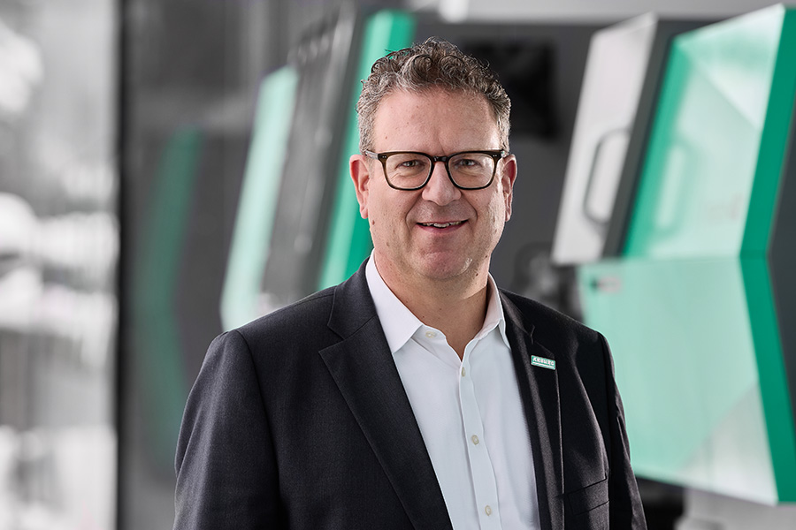

On 12 January 2026, Dr Volker Nilles took up the position as Chief Executive Officer of Arburg.

Photo: ARBURG
Photo download:
https://media.arburg.com/web/8c5024d3c0f5cd83/dr--volker-nilles/

Press release
File: Pressemitteilung Neuer CEO_en_GB.docxx
Characters: 2.321
Words: 342

This and other press releases are available for download from our website at www.arburg.com/de/presse/ (www.arburg.com/en/press/)

Contact
ARBURG GmbH + Co KG
Press office
Susanne Palm
Dr Bettina Keck
Postfach 1109
72286 Lossburg, Germany
Tel.: +49 7446 33-3463
Tel.: +49 7446 33-3259
presse_service@arburg.com

About Arburg
The German family-owned company, established in 1923, is one of the leading global manufacturers of injection moulding machines. The Arburg family also includes AMKmotion, which manufactures electric drive systems.
Arburg’s portfolio for plastics processing includes Allrounder injection moulding machines, robotic systems and customer- and industry-specific turnkey solutions. It also includes digital products and services. Arburg is a pioneer in the plastics industry when it comes to energy and production efficiency, digitalisation and sustainability. Arburg machines are used to manufacture plastic products for industries such as mobility, packaging, electronics, medicine, construction and equipment engineering, and leisure.
The company headquarters are located in Lossburg, Germany. In addition, Arburg has its own organisations at 37 locations in 27 countries and, together with trading partners, is represented in over 100 countries. Of a total of around 3,450 employees, some 2,850 work in Germany while around 600 are based in Arburg organisations around the world.
Arburg is certified in accordance with ISO 9001 (quality), ISO 14001 (environment), ISO 27001 (information security), ISO 29993 (training) and ISO 50001 (energy).
Further information: www.arburg.com, www.amk-motion.com.

