Arburg Newcomer Awards 2026
Supporting young MINT talent!

- Arburg honours young talent from regional schools
- Newcomer Awards presented on 25 March
- Outstanding projects and actions once again

Lossburg, 27/03/2026
On 25 March, the winners of the Arburg Newcomer Awards 2026 were honoured during a ceremony at the Vocational Training Center at the company’s headquarters in Lossburg. Through this competition, Arburg supports young MINT talents from partner schools in the Black Forest region, Germany. This year, the prizes went to five winners: two to final-year A-level students at the Heinrich-Schickhardt-Schule in Freudenstadt, and three to secondary school pupils at the Falkenrealschule in Freudenstadt and the John-Bühler Realschule in Dornhan. The award-winning projects focused, among other things, on automotive engineering and mechanical and physical VR applications.

“All schools in the local area that have signed a cooperation agreement with us can take part in the Newcomer Award and nominate potential winners,” says Michael Vieth, Director Apprenticeship at Arburg. This was done by the teachers of pupils at secondary and grammar schools. “We take several criteria into account during the selection process for the winners,” explains trainer Marius Singer. “In addition to aptitude in the MINT subjects – mathematics, information technology, natural sciences and technology – we also look at personal initiative and outstanding commitment both in and out of school. In 2026, for example, this included participation in chemistry and physics laboratory exercises or in the Chemestree 2025 chemistry competition.”

Committed pupils
This year, two of the Newcomer Awards went to grammar school pupils Jan Gretscher and Jonas Daniel Birlinger, and three to secondary school pupils Diana Slizkov, Samira Pfaff and Lucas Sagel.
- Diana Slizkov (Falkenrealschule Freudenstadt) is actively involved in a wide range of scientific and technical activities. For example, she designed her own open-top racing car, carried out its installation from metal and fitted it with electric LED lighting effects. In her school’s chemistry club, she and other pupils created a very special ‘Christmas tree’. Instead of baubles, test tubes were hung from the branches, in which chemical substances reacted with one another, causing the mixtures to glow or even burn.
- Lucas Sagel (John-Bühler Realschule, Dornhan) loves working with wood. For example, he has built a miniature house, which he is constantly adding to. He also sculpts his own statues from modelling clay.
- Samira Pfaff (John-Bühler Realschule, Dornhan) describes mathematics and technology as her passions. She enjoys tinkering in her own workshop, where she has built a car that moves on its own, made out of wood. She has also successfully completed an internship in architecture.
- Jan Gretscher (Heinrich-Schickhardt-Schule in Freudenstadt), on the other hand, is particularly interested in the cool experiments in chemistry as well as specific areas of technology. These are offered as optional subjects at his school. Like his older brother, he definitely wants to dive deeper into technology later on.
- Jonas Daniel Birlinger (Heinrich-Schickhardt-Schule, Freudenstadt) is particularly interested in the combination of mechanics and electrical engineering and has therefore already completed an internship in mechatronics. As part of a study-integrated apprenticeship (SIA) at the Dual Universities of Baden-Württemberg, he intends to work on a VR application to develop basic mechanical and physical knowledge.

Ceremony at the Arburg Vocational Training Center
The award ceremony took place during an evening event at the Arburg Vocational Training Center in Lossburg. Parents and teachers were also invited to the prize-giving ceremony. The event began with a tour of the Customer Center and ‘Evolution’, where the company’s history can be experienced first-hand and in a practical way. This was followed at the Vocational Training Center by a presentation of Arburg’s triple-certified training concept, as well as a concise overview of the company’s training programmes. Short interviews with the award-winning students about their projects provided interesting insights into their work. Afterwards, Stefan Beck, Vice President Global HR at Arburg, Michael Vieth and Marius Singer presented the prizes and certificates to the wnners.

Image

Newcomer Award DE 2026_M1A0029

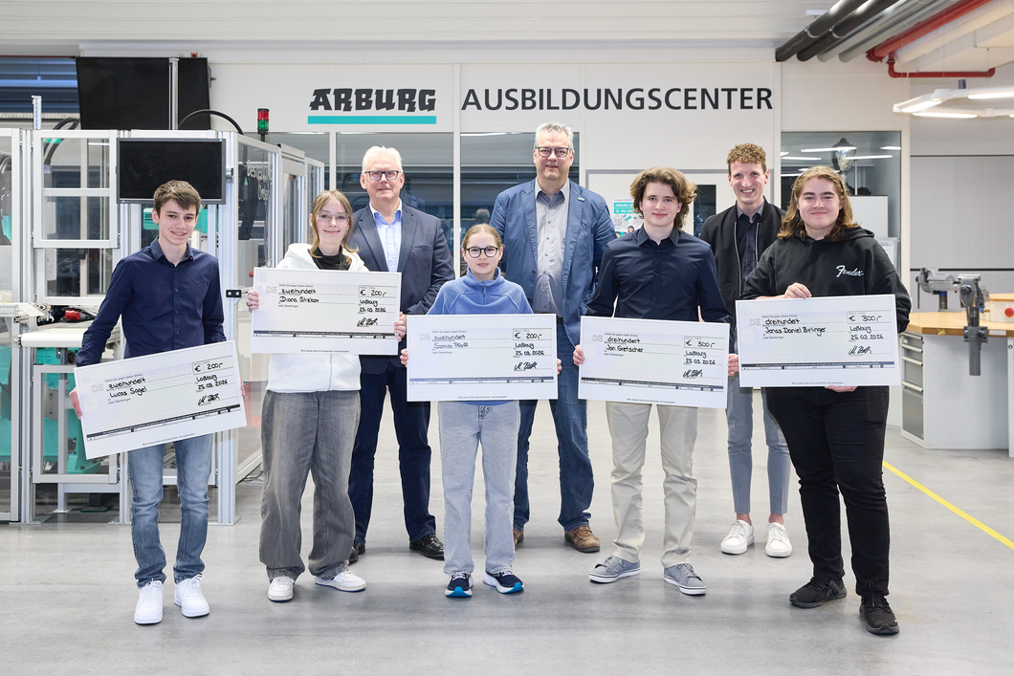

The winners of the Arburg Newcomer Awards 2026: Lucas Sagel, Diana Slizkov, Samira Pfaff, Jan Gretscher and Jonas Daniel Birlinger (front row, from left) were delighted to receive their cash prizes, alongside Stefan Beck, Arburg Vice President Global HR (third from left), Michael Vieth, Director Apprenticeship (centre) and Trainer Marius Singer (second from right).

Photo: ARBURG

Photo download:
https://media.arburg.com/web/6316cd112dd15a33/newcomer-preise-2026/

Press release
File: ARBURG Press release Newcomer Awards 2026_en_GB.docx
Characters: 4,186
Words: 619

This and other press releases are also available for download on our website at www.arburg.com/de/presse/ (www.arburg.com/en/presse/).

Contact
ARBURG GmbH + Co KG
Press Office
Susanne Palm
Dr Bettina Keck
P.O. Box 1109
72286 Lossburg, Germany
Tel.: +49 7446 33-3463
Tel.: +49 7446 33-3259
presse_service@arburg.com

About Arburg
Founded in 1923, the German family-owned company is one of the world's leading manufacturers of injection moulding machines. The Arburg family also includes AMKmotion, a manufacturer of electric drive technology.
The Arburg portfolio for plastics processing includes Allrounder injection moulding machines, robotic systems and customer- and industry-specific turnkey solutions. It also offers digital products and services. Arburg is a pioneer in the plastics industry in the areas of energy and production efficiency, digitalisation and sustainability. Arburg machines are used to manufacture plastic products for industries such as mobility, packaging, electronics, medicine, construction and apparatus engineering, and leisure.
The company headquarters are located in Lossburg, Germany. Arburg also has its own organisations in 27 countries at 37 locations and is represented in over 100 countries together with trading partners. Of the total workforce of around 3,400, around 2,800 are employed in Germany and around 600 in Arburg organisations worldwide.
Arburg is certified according to ISO 9001 (quality), ISO 14001 (environment), ISO 27001 (information security), ISO 29993 (training) and ISO 50001 (energy).
Further information: www.arburg.com, www.amk-motion.com.

