Expansion for the future
Arburg acquires Stork IMM

- Strategic expansion: Arburg portfolio growing in large and packaging machines
- Tailor-made expansion: Combination of two strong brands
- Clear win-win situation: Companies and customers set to benefit

Lossburg/ Hengelo, 30/07/2026
A historic moment: On 29 July 2026, CFO Steffen Kroner and CTO Guido Frohnhaus signed the purchase agreement on behalf of Arburg, while Philip Stibbe, shareholder of Stork IMM and founder of Stibbe Participaties, signed on behalf of Stibbe Participaties B.V. Under the agreement, Arburg will acquire Stork Plastics Machinery B.V. (Stork IMM), based in Hengelo, the Netherlands, from Stibbe Participaties B.V. With this step, both companies are strengthening their position in the global market for plastic injection moulding machines.

The acquisition is taking place against the background of a changing injection moulding market, in which volatile developments, lower volumes, increasing international competition and economies of scale are playing an increasingly important role.

Two strong brands united
“By purchasing Stork IMM, we are investing strategically in the future with a focused and long-term view”, says Dr Volker Nilles, CEO of Arburg, “and in this way want to strengthen Arburg’s position in the global injection moulding market. With this acquisition, two strong brands that have been well known on the market for many decades are now coming together: a clear win-win situation for everyone, and especially for customers.” With this strategic investment, Arburg is sending a clear signal to the global market: “We are here for you, in both good and challenging times!”

Perfect complement to the Arburg portfolio
Stork IMM is known in the premium segment for its large, high-speed injection moulding machines for thin-wall packaging. “The Stork machines are therefore ideally suited to extending the Arburg portfolio very quickly – but with a lasting and long-term impact – and strategically to include machines with a clamping force in excess of 5,000 kN and for the packaging industry“, says Nilles.

Assuring the future for Stork IMM
Eric Pans, CEO at Stork IMM, adds: “The acquisition by Arburg will help to strengthen and expand Stork’s business activities, among other things through international sales and service capacities, a broader product range, synergies in purchasing and supply chain, as well as further professionalisation of processes.“
Philip Stibbe commented: “In Arburg we have found a highly complementary strategic partner who shares our family values, long-term perspective and commitment to European manufacturing. We are convinced that this combination offers an excellent foundation for the continued development and long-term success of Stork IMM.”

Finalisation in September
With the signing of the purchase agreement on 29 July 2026, the first official step has now been taken. The acquisition is expected to be completed in around two months.

Photo

Signing ARBURG Stork IMM NL 2026_1JLF0544 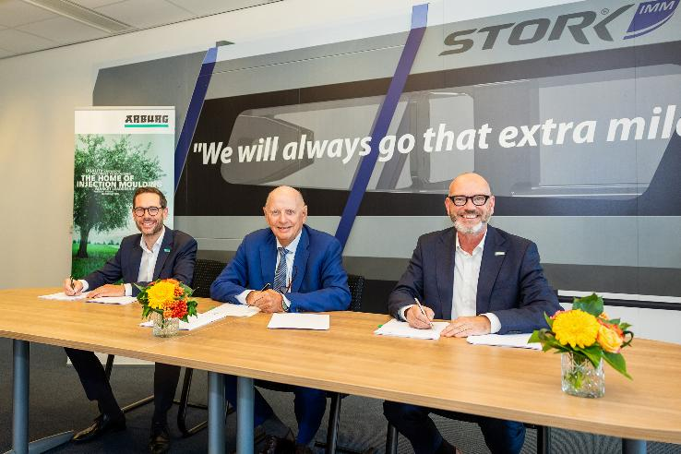Arburg acquires Stork IMM (from left): The purchase agreement was signed by Steffen Kroner, CFO of Arburg, Philip Stibbe, shareholder of Stork IMM and founder of Stibbe Participaties, and Guido Frohnhaus, CTO of Arburg, on 29 July 2026 in Hengelo, the Netherlands.

Photo: JLF Foto & Filmstudio

Photo download:
https://media.arburg.com/web/c4243fc5f7f08166/signing-arburg-stork-imm/

Press release
File: ARBURG Pressemitteilung Kauf Stork IMM_en_GB.docx
Characters: 2,680
Words: 408

This and other press releases are available for download from our website at www.arburg.com/de/presse/ (www.arburg.com/en/press/)

Contact
ARBURG GmbH + Co KG
Press office
Susanne Palm
Dr Bettina Keck
Postfach 1109
72286 Lossburg, Germany
Tel.: +49 7446 33-3463
Tel.: +49 7446 33-3259
presse_service@arburg.com

About Arburg
The German family-owned company, established in 1923, is one of the leading global manufacturers of injection moulding machines. The Arburg family also includes AMKmotion, which manufactures electric drive systems.
Arburg’s portfolio for plastics processing includes Allrounder injection moulding machines, robotic systems and customer- and industry-specific turnkey solutions. It also includes digital products and services. Arburg is a pioneer in the plastics industry when it comes to energy and production efficiency, digitalisation and sustainability. Arburg machines are used to manufacture plastic products for industries such as mobility, packaging, electronics, medicine, construction and equipment engineering, and leisure.
The company headquarters are located in Lossburg, Germany. In addition, Arburg has its own organisations at 37 locations in 27 countries and, together with trading partners, is represented in over 100 countries. Of a total of around 3,400 employees, some 2,800 work in Germany while around 600 are based in Arburg organisations around the world.
Arburg is certified in accordance with ISO 9001 (quality), ISO 14001 (environment), ISO 27001 (information security), ISO 29993 (training) and ISO 50001 (energy).
Further information: www.arburg.com, www.amk-motion.com.

