Arburg at Fakuma 2026
Smartest Factory: Digitalisation across the complete value chain

- Comprehensive: Digital Arburg services and software for greater efficiency, transparency and flexibility
- Adding value: Development and planning, set-up and production, service and analysis
- Smart: From machines with digital assistants through to production cells and networked production

Lossburg, 29/09/2026
At Fakuma 2026, Arburg (Stand 3101, Hall A3) is showcasing its comprehensive portfolio of digitalisation solutions across the complete value chain in the central exhibition area designated ‘Digital Services and Software’. Trade visitors will learn how Arburg supports its customers on their journey towards their ‘Smartest Factory’ goal with products, services and comprehensive expertise – from injection moulding machines with assistants and pilots, through automated production cells, to digitally interlinked plastics parts production. On display will be, for example, the new Gestica lite control system, new assistance functions, and new features of the arburgXworld customer portal as well as Arburg’s own MES (ALS).

Digitalisation makes it possible to tap the full potential of plastic part production, leading to greater efficiency, transparency and flexibility, while also ensuring the lowest possible unit costs and delivering significant competitive advantages. With its ‘Smartest Factory’ focus, Arburg highlights all areas of optimisation potential along the value chain – from development and production planning through set-up and serial production to maintenance, service and analysis. Experts demonstrate at simulators and exhibits all the features and, in one-to-one discussions, explain how these interlock effectively and work together optimally.

40 years of Arburg MES – greater efficiency and transparency
In 2026, Arburg’s in-house developed host computer system (ALS) will celebrate its 40th anniversary. To mark the occasion, there will be special offers for customers from Fakuma onwards. A new feature at Fakuma 2026 is, for example, an MES cloud solution hosted by Arburg. With this monthly-billed service, customers avoid the need for a high one-off investment and the costs associated with maintaining their own MES infrastructure, including IT staff, while at the same time enhancing data security.
The modular MES from Arburg helps maintain an overview by visualising information on, for example, machines, employees, articles, statuses and priorities, and enables flexible order planning in real time. The MES not only creates transparency in production but also increases Overall Equipment Efficiency (OEE) by an average of over 26 per cent. On the new ‘MachineTerminal’ home screen, all machines and their availability can be viewed on the go, with a simple option to navigate directly to individual machines.
Furthermore, ALS now offers new functions incorporating artificial intelligence (AI), for example in program analysis and management. The AI-supported, automated analysis of key indicators at the touch of a button is particularly helpful. This saves time and provides users with valuable tips on how to improve their OEE. This analysis can be explored in greater depth by asking questions via a chatbot.

Customer portal apps provide support day-to-day
The arburgXworld customer portal, which currently has over 22,000 users worldwide, can be integrated with the MES or used independently of it. Its numerous apps covering all injection moulding tasks – from the selection of the right machine and process optimisation directly on the personal computer to providing active support in the event of malfunctions – simplify day-to-day work, prevent errors and boost productivity. Here, too, AI is playing an increasingly significant role. For example, the premium app ‘Ask Arburg’ contains easily accessible, comprehensive injection moulding knowledge from Arburg and, with the aid of AI, can answer specific questions about all Arburg products and processes relating to injection moulding and can also analyse faults. The app can access machine-specific documents as well as the material database from ‘MachineFinder’, including relevant recommendations for processing the respective material.
In the customer portal app “Virtual Control – the virtual twin of Gestica lite” – each setup can be planned in advance by a central expert located away from the machine. This not only makes it possible to optimise a programme directly on the PC, but also to run it in automatic cycle mode to further improve process and cycle times and to minimise unproductive times.
The Premium Connect app ‘MachineDashboard’ now includes the ‘aXw Control StabilityAssist’ function.

Central control system with smart assistants and pilots
The ‘StabilityAssist’ monitors continuously key parameters and detects gradual deviations. This enables users to have the AI-based control assistant display predictive parameter trends for all their machines integrated into the customer portal, and to receive timely push notifications before any unscheduled downtime occurs. When there is a coupling with the Arburg MES, this is even possible for third-party machines. These and other smart assistance and pilot functions guide the operator safely through the processes, enable predictive maintenance of moulds and machinery, and ensure the required part quality, high process stability and reduced unit costs, even in the face of changing conditions and materials.

At Fakuma 2026, all exhibits will be equipped with several assistant or pilot functions. In the case of the Allrounder 1000 e Trend electric machine, these include, for example, the following innovative controller functions:
- The new ‘aXw Control FirstShotAssist’ function supports the set-up operator during production start-up. A unique selling point for Arburg is that the component geometry data is read directly into the injection moulding machine. Based on this, as well as existing material and machine data, this digital assistant calculates recommendations for suitable start-up parameters (First Shot) during initial sampling. This reduces the time required to produce the first good part and does not require any specialist knowledge.
- The ‘aXw Control DoEAssist’ for process optimisation brings structured validation in the form of ‘Design of Experiments’ (DoE) directly to the injection moulding machine. Once the set-up engineer has specified which parameters are to be tested in practice, the control system automatically generates a test plan which the machine then executes in a structured manner. The efficient planning, execution of trials, removal of test parts and documentation ensures reliable and efficient validation.
- The ‘aXw Control MouldSafetyAssist’ uses a reference curve to precisely detect changes in the force curve, stops the closing movement if necessary, and thus reliably protects the mould from damage.

Benchmark: ‘NextGen Medical Solution’ production cell
A highlight in terms of digital connectivity is the ‘NextGen Medical Solution’ – a turnkey system centred around an Allrounder 570 A electric machine. Arburg developed this system in collaboration with expert partners and with a renowned OEM in the medical technology sector. Using the injector pen as a product example, the system demonstrates the significant benefits offered by the consolidation of all data within the Gestica control system, as well as its numerous smart pilot and assistance functions. The ‘aXw Control MoldlifeAssist’ monitors the mould throughout its entire life cycle using integrated sensor technology in order to prevent unplanned downtime. Moreover, the software from partner Plus 10, which is fully integrated into the control system, utilises AI. This software analyses machine and process data in real time, automatically detects deviating patterns, learns correlations between process parameters and quality, and suggests potential improvements.
Further assistance and pilot functions on this benchmark system for medical technology include:
- The ‘aXw Control FillAssist’ for simulating the filling behaviour of the moulded part directly within the machine controller,
- the ‘aXw Control DoEAssist’ for the rapid determination of the correct process window,
- the ‘EnergyAssist’ for energy-efficient heating or switching to standby for the cylinder module,
- the ‘ARBURG FlowPilot’ for regulated mould temperature regulation,
- the ‘aXw Control MeltAssist’ for optimised utilisation of the plasticising unit and optimised residence times,
- the ‘aXw Control CycleAssist’ for the elimination of unproductive times during the cycle,
- the ‘aXw Control PressurePilot’ with bionically optimised pressure regulation for consistent mould filling,
- and the ‘aXw Control StabilityAssist’ for increased process stability.

Together, all these features significantly reduce scrap and improve part quality. The results are cost-efficiency, and reduced energy requirement, whilst maintaining high availability, productivity and part quality.
(For more information about this application, see the NextGen Medical press release)

Images

Key visual for FAKUMA 2026

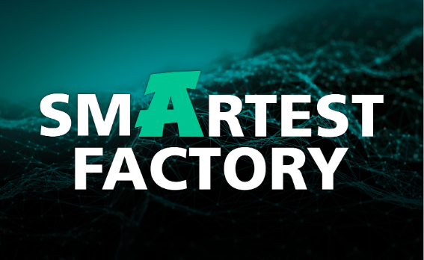

‘Smartest Factory’ is Arburg’s focus at Fakuma 2026.

Graphic: Digital Services and Software Fakuma 2026

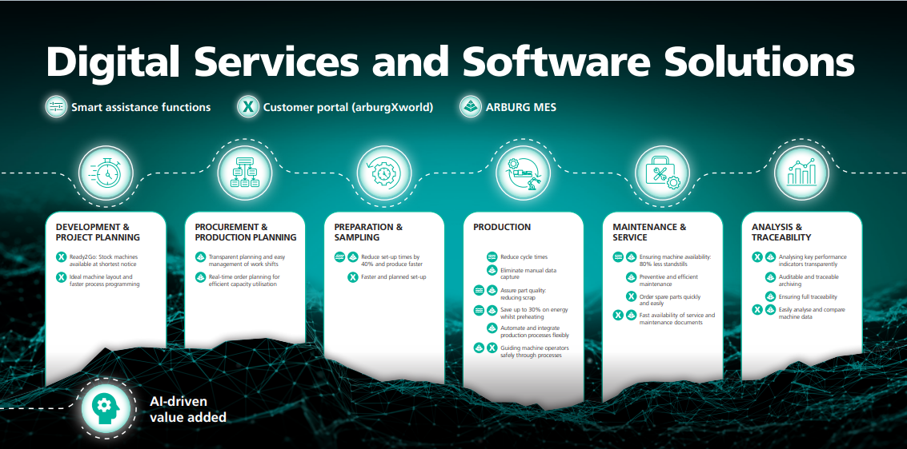

With its ‘Smartest Factory’ focus, Arburg highlights the potential for optimisation offered by digital services and software solutions across the value chain.

GESTICA lite DE_DSC6996
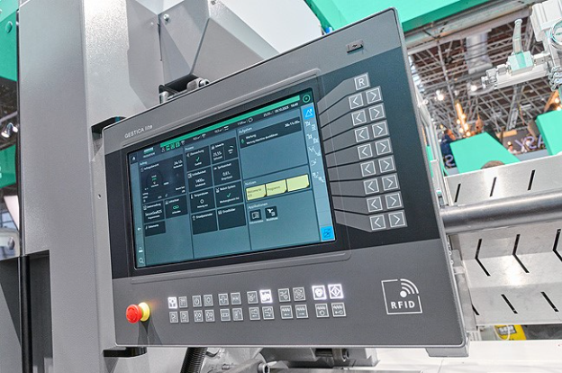
The new Gestica lite control system features a clear dashboard and numerous smart assistance and pilot functions.

570A GESTICA DE MoldlifeAssist_D1A0922
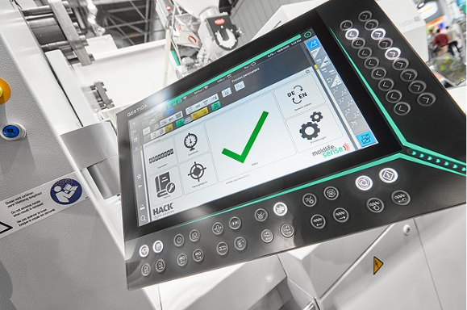
‘Smart’ communication between the machine and the injection mould is made possible by ‘aXw Control MoldlifeAssist’, which is fully integrated into the Gestica control system.

Photos: ARBURG

Photo download:
https://media.arburg.com/web/9daf5992e504c22b/smart-factory-fakuma-2026/

Press release
File: Pressemitteilung Smart Factory Fakuma 2026_en_GB.docx
Characters: 8,626
Words: 1,245

This and other press releases are available for download from our website at www.arburg.com/de/presse/ (www.arburg.com/en/press/)

Contact
ARBURG GmbH + Co KG
Press office
Susanne Palm
Dr Bettina Keck
Postfach 1109
72286 Lossburg, Germany
Tel.: +49 (0)7446 33-3463
Tel.: +49 (0)7446 33-3259
presse_service@arburg.com

About Arburg
Founded in 1923, the German family-owned company is one of the world's leading manufacturers of injection moulding machines. AMKmotion, a manufacturer of electric drive technology, also belongs to the Arburg family.
The portfolio for plastics processing encompasses Allrounder injection moulding machines, robot systems as well as customer- and industry-specific turnkey solutions. It also includes digital products and services. Arburg is a pioneer in the plastics industry when it comes to energy and production efficiency, digitalisation and sustainability. Arburg machines are used to manufacture plastic products for the mobility, packaging, electronics, medical, construction and equipment engineering and leisure industries, for example.
The company headquarters are located in Lossburg, Germany. In addition, Arburg has own organisations in 27 countries at 37 locations and is represented in over 100 countries together with trading partners. Of a total of roughly 3,300 employees, about 2,700 work in Germany, with another 600 employees based in Arburg's organisations around the world.
Arburg is certified to ISO 9001 (Quality), ISO 14001 (Environment), ISO 27001 (Information Security), ISO 29993 (Education and Training) and ISO 50001 (Energy).
Further information: www.arburg.com, www.amk-motion.com.

