New Regional Manager APAC at Arburg
Bharat Sharma reinforces the international management team

- Reinforcement: Bharat Sharma takes over as Regional Manager for the Asia-Pacific region
- Experience: International expertise in industrial automation and market development
- Objective: Further expansion of Arburg’s market position and customer focus

Lossburg, 26/10/2026
With effect from 1 October 2026, Arburg has reinforced its international management team: Bharat Sharma has taken on the role of Regional Manager APAC, assuming responsibility for the Asia-Pacific region. Within this sales region, the company has its own subsidiaries in Malaysia, Indonesia, Singapore, Taiwan, Thailand and Vietnam. The other countries in the region are served by distribution partners, some of whom have been working with Arburg for many decades.

Bharat Sharma has many years’ experience in industrial automation and has held senior positions at renowned companies. In these roles, his responsibilities included expanding strategic customer and partner networks, successfully developing international markets and leading global teams.
He has also achieved sustainability in terms of market and revenue growth and has successfully implemented key growth initiatives.

Arburg expands into a key growth region
In Bharat Sharma, Arburg has therefore gained an experienced leader with extensive international expertise and an in-depth understanding of the requirements of customers and markets in the Asia-Pacific region.
This ideally places the new Regional Manager APAC to expand Arburg’s market position in this key growth region and to further strengthen the company’s close ties with customers and partners.
Zhao Tong will continue to be responsible for the China region. The Regional Manager for the Americas is Martin Baumann, with Steffen Eppler as Regional Manager for Europe.

Image

Sharma Bharat Regional Manager APAC

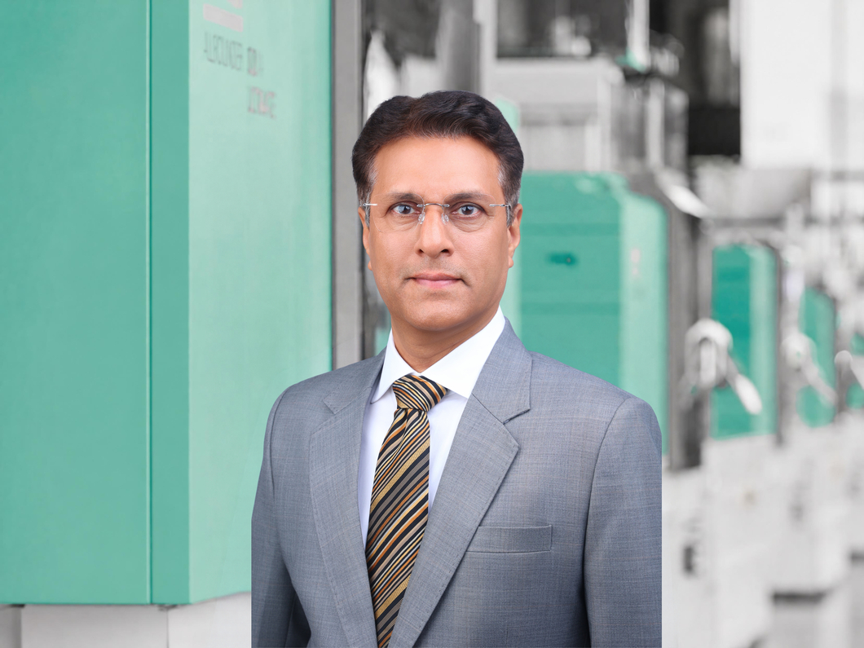

Since 1 October 2026, Bharat Sharma has been responsible for the Asia-Pacific sales region as Arburg’s Regional Manager APAC.

Photo: ARBURG
Photo Download:
https://media.arburg.com/web/4a698565e7485f92/regional-manager-apac-2026-press-release/

Press release
File: Pressemitteilung neuer Regionalleiter APAC 2026_en_GB.docx
Characters: 1,495
Words: 220

This and other press releases are available for download from our website at www.arburg.com/de/presse/ (www.arburg.com/en/press/)

Contact
ARBURG GmbH + Co KG
Press office
Susanne Palm
Dr Bettina Keck
Postfach 1109
72286 Lossburg, Germany
Tel.: +49 (0)7446 33-3463
Tel.: +49 (0)7446 33-3259
presse_service@arburg.com

About Arburg
Founded in 1923, the German family-owned company is one of the world's leading manufacturers of injection moulding machines. The portfolio for plastics processing encompasses Allrounder injection moulding machines, robotic systems as well as turnkey solutions that are designed customer- and industry-specific. This portfolio also includes digital products and services.
Stork IMM, a manufacturer of large, high-speed injection moulding machines for thin-walled packaging, and AMKmotion, a manufacturer of electric drive technology, also belong to the Arburg family.
Arburg is a pioneer in the plastics industry when it comes to energy and production efficiency, digitalisation and sustainability. Arburg machines are used to manufacture plastic products for sectors such as mobility, packaging, electronics, medical, construction and equipment engineering and leisure industries, for example.
The company headquarters are located in Lossburg, Germany. In addition, Arburg has own organisations in 27 countries at 37 locations and is represented in over 100 countries together with trading partners. Of a total workforce of roughly 3,300 employees, about 2,700 are based in Germany, with the remaining 600 employed in Arburg's organisations around the world.
Arburg is certified to ISO 9001 (Quality), ISO 14001 (Environment), ISO 27001 (Information Security), ISO 29993 (Education and Training) and ISO 50001 (Energy).
Further information: www.arburg.com, www.storkimm.com, www.amk-motion.com.

