Sustainability Report 2025
Tangible achievements: The new Sustainability Report is here!

- Transparent: figures, facts and activities of the successful arburgGREENworld program
- Consistent: Investing in sustainability even in difficult times
- Resource-efficient: Report available online only

Lossburg, 04 August 2026
Sustainability is more than just a goal – it is a responsibility towards future generations. The 2025 Sustainability Report demonstrates that this important issue is firmly rooted in Arburg’s DNA. Its publication highlights the successes and progress of the arburgGREENworld program worldwide, backed up by compelling figures, facts and activities. It also shows how the company is consistently continuing on the path towards a more sustainable future. In the interests of resource conservation, the Arburg Sustainability Report 2025 is available exclusively online as an interactive PDF on the ARBURG website.

Arburg has now been publishing a sustainability report for five years to highlight the successful activities and measures of the arburgGREENworld program. In addition to the topics of resource efficiency, circular economy and CO₂ footprint, this also encompasses Arburg’s entire ESG (Environmental, Social, Governance) strategy.

Embracing sustainability holistically
This continuity demonstrates that, even in 2025 and despite the persistently challenging economic and global conditions, the company remains committed to driving forward sustainability and resource conservation – and to not only talking about environmental responsibility but also putting it into practice. Arburg not only operates in a resource-efficient manner itself but is also a solution partner for its customers in the field of sustainable plastics processing.

EcoVadis Gold Award
The fact that Arburg continued to operate in a sustainable manner in 2025 is demonstrated, amongst other things, by the company being awarded the EcoVadis Gold rating for the third year running, despite the criteria becoming more demanding with each passing year. Compared with the previous year, Arburg had improved once again in all categories – from a total of 78 to 83 points – and is thus ranked among the top two per cent of more than 100,000 companies. These companies were assessed by an independent body in terms of environmental performance, labour and human rights, ethics and sustainability of procurement. Furthermore, the ‘B’ rating in the 2025 CDP assessment assigns Arburg a position above average compared to other engineering companies in the areas of climate protection, ecology and CO₂ emissions.

Strong indicators demonstrate success
The success of the activities and measures relating to resource efficiency, the circular economy and the CO₂ footprint is demonstrated by the following figures:
- In 2025, Arburg’s electricity mix had a CO₂ footprint up to 86 per cent lower than that of the German electricity mix.
- Arburg generated around 2,900,000 kWh of solar power for its own use via photovoltaic systems in 2024.
- The proportion of self-generated electricity from renewable sources stood at almost 16 per cent.
- 140,000 tonnes of CO₂ emissions were saved between 2010 and 2025.
- Almost 30 per cent of Arburg’s total water consumption comes from rainwater collected in cisterns.
- 77 per cent of total waste generated was recycled in 2025.

Many more impressive figures, as well as fascinating examples of the activities, measures and progress made under the arburgGREENworld program, are compiled in the Arburg Sustainability Report 2025. This is available online on the website (https://www.arburg.com/media/daten/other/sustainability-report-2025_en.pdf).

Photo

Sustainability Report 2025 EN

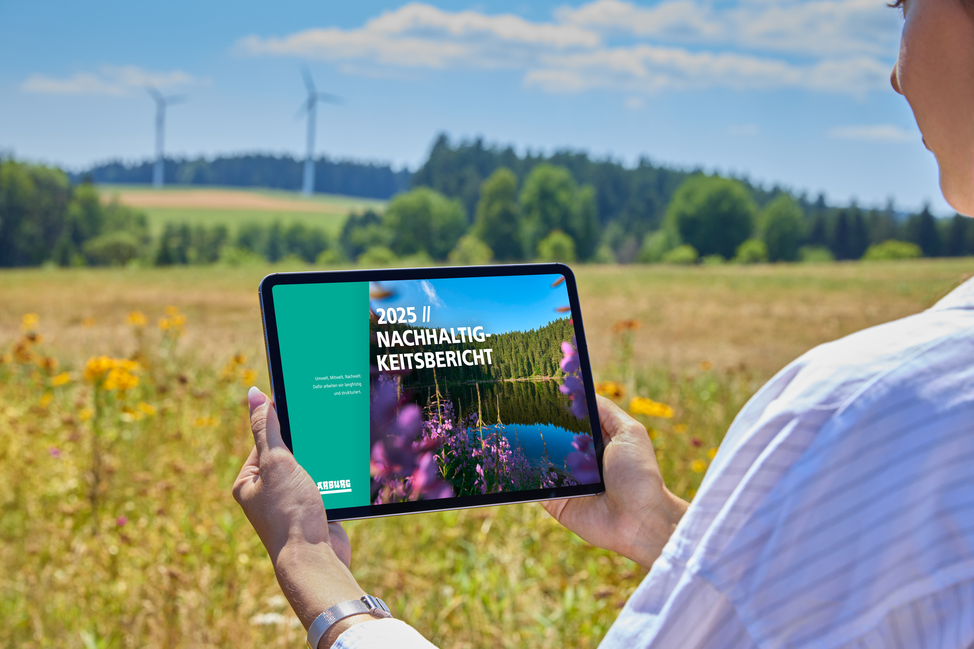

Conserving resources: Arburg is publishing its 2025 Sustainability Report exclusively online.

Photo: ARBURG
Photo download:
https://media.arburg.com/web/ae70d16f2806720/sustainability-report-2025-/

Press release
File: Pressemitteilung Nachhaltigkeitsbericht Jahr 2025_en_GB.docx
Characters: 3,339
Words: 490

You can also download this and other press releases from our website at www.arburg.com/de/presse/ (www.arburg.com/en/presse/)

Contact
ARBURG GmbH + Co KG
Press Office
Susanne Palm
Dr Bettina Keck
PO Box 1109
72286 Lossburg
Tel.: +49 7446 33-3463
Tel.: +49 7446 33-3259
presse_service@ARBURG.com

About ARBURG
Founded in 1923, this German family-owned company is one of the world’s leading manufacturers of injection moulding machines. The ARBURG family also includes AMKmotion, a manufacturer of electric drive systems.
ARBURG’s portfolio for plastics processing comprises Allrounder injection moulding machines, robotic systems and customer- and industry-specific turnkey solutions. It also includes digital products and services. Within the plastics industry, Arburg is a pioneer in the areas of energy and production efficiency, digitalisation and sustainability. Arburg machines are used to manufacture plastic products for industries such as Mobility, Packaging, Electronics, Medical, Construction and equipment engineering, and Leisure.
The company’s headquarters are in Lossburg, Germany. Furthermore, ARBURG has its own organisations in 27 countries at 37 locations and, together with its distribution partners, has representation in over 100 countries. Of the total workforce of around 3,400 employees, approximately 2,800 are based in Germany and around 600 work in ARBURG’s organisations worldwide.
ARBURG is certified to ISO 9001 (quality), ISO 14001 (environment), ISO 27001 (information security), ISO 29993 (training) and ISO 50001 (energy).
Further information: www.arburg.com, www.amk-motion.com.

