University competition Competition for design Design and sustainability Sustainability in Italy

“Pleiades” reinforces the positive image of plastic as a material

- Award-winning: “donut-ella” by design students at IUAV Vicenza
- Cross-disciplinary: Cooperation between universities, companies and institutions brings together design, sustainability and industrial manufacturing
- Practical: Allrounder 1000 e Trend to manufacture winning product

Venice/Lossburg, 16 January 2026
With the university competition “Pleiades – Plastic European Innovation Award for Design and Sustainability”, leading companies in the plastics industry, together with IUAV University in Venice, are presenting a project that makes the importance of design, sustainability and industrial manufacturing using injection moulding visible and tangible. The award ceremony took place on 11 December 2025 at the Palazzo Badoer of IUAV University in Venice. The competition was supported by Arburg, Chem Trend, Ewikon Hot Runner Systems, Febo E&R Polymer and Uniform Srl, together with the trade associations TMP (Association of Plastics Technicians) Italy, Women in Plastic Italy, the Fondazione Studi Universitari di Vicenza (Vicenza University Studies Foundation) and the German-Italian Chamber of Commerce AHK Italy.

The aim of this initiative is to highlight the value of durable plastic products and to strengthen cooperation between industry and academic institutions. It is aimed at students of the Bachelor’s degree course in Design at the IUAV in Vicenza. Their task: To develop a small gadget made of recycled plastic and to describe it in technical detail. With this task, the initiative focuses on the benefits of plastic parts of this kind.

"donut-ella" is the winner
Students submitted a total of 38 designs. The winning project was selected by an interdisciplinary jury that included representatives from all supporting companies. Arburg was represented on the decision-making committee by Ivan Panfiglio, Area Manager at Arburg in Italy, by Christian Homp, Manager of Applications at Arburg headquarters in Lossburg and by Jonas Bletscher, a member of Christian’s team.
The winning design is called “donut-ella” and was created by Caterina Gasparini, Matteo Bazzacco and Paolo Levorato from IUAV in Vicenza. It is a three-part cable winder shaped rather like a doughnut. This gadget prevents cable clutter and is compact, functional as well as easy to transport. This intriguing design is just intended to be useful in everyday life. It also aspires “to consciously evoke joy” – an example of how design and practicality can interact successfully in the plastics sector.

Award ceremony in Venice
After a welcome by representatives of IUAV University of Venice, Prof. Laura Badalucco and Prof. Luca Casarotto presented the project in detail. The subsequent award ceremony, at which a cheque for 2,000 Euros was presented to the winner, was conducted by German Consul General Susanne Welter from Milan. To conclude this event, experts from the industry and related trade associations – including representatives from the companies, Women in Plastic Italy and TMP – discussed the importance of encouraging talented young people, sustainable product design and the role of injection moulding in a modern circular economy. For the companies involved, “Pleiades” exemplifies how innovation, design culture and industrial manufacturing go hand in hand.

“Pleiades” brings together key players in Italy’s plastics industry
Ivan Panfiglio emphasised the special significance of the project, which brings together the entire plastics supply chain, promotes networking within the industry and at the same time conveys a positive image of plastics as a material: “This initiative brings creativity to the industry, while students gain valuable insights into industrial reality – added value with long-term benefits for both parties. “Pleiades” is a format that not only highlights the importance of high-quality injection moulding, but also shows how education, cooperation and innovation can strengthen the sustainable and responsible use of plastics”.

"donut-ella" will be manufactured at Arburg in 2026
The winner of the competition will have the opportunity to have their design manufactured industrially and then presented at international trade fairs and events organised by Arburg. The mould will be manufactured by Uniform and equipped with hot runner systems from Ewikon. The PA6 material used will be supplied by CGT and processed on a new electric Allrounder 1000 e Trend with a clamping force of 1,000 kN. The project will be presented to an international audience for the first time at the Arburg Technology Days from 11 to 13 March 2026 in Lossburg, at which this product will be manufactured live.

Images

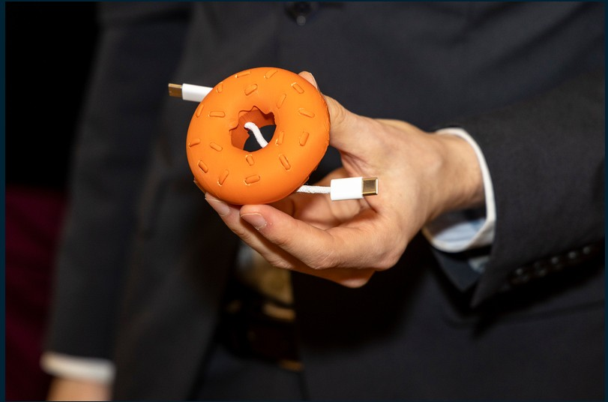

The winning gadget is called “donut-ella” and looks like the world-famous pastry. It is designed to make tangled cables a thing of the past when winding and unwinding USB cables.

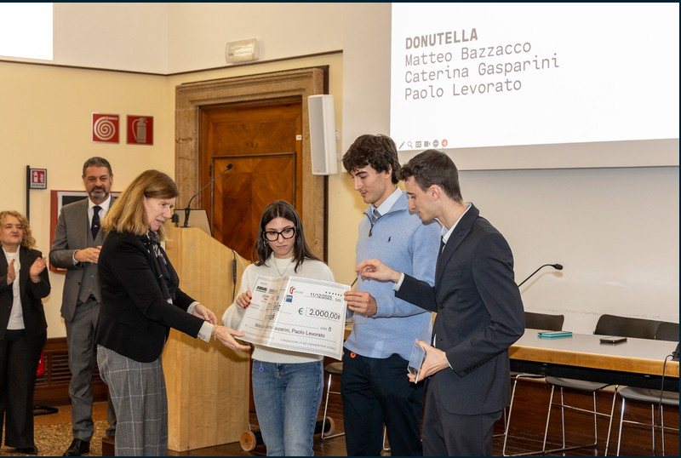

German Consul General Susanne Welter (left) presented the 2000 Euros first prize to Caterina Gasparini, Matteo Bazzacco and Paolo Levorato, students of the Bachelor's degree course in Design at IUAV in Vicenza (from left).

Photos: ARBURG

Photo download:
https://media.arburg.com/web/ab7bc6043d5970ec/design-award-pleiades/

Press release
File: Pressemitteilung Designpreis Pleiades Italien_en_GB.docx
Characters: 4,396
Words: 559

This and other press releases are also available for download on our website at www.arburg.com/de/presse/ (www.arburg.com/en/presse/).

Contact
ARBURG GmbH + Co KG
Press Office
Susanne Palm
Dr Bettina Keck
P.O. Box 1109
72286 Lossburg
Tel.:
Tel.: +49 7446 33-3259
presse_service@arburg.com

About Arburg
Founded in 1923, the German family-owned company is one of the world's leading manufacturers of injection moulding machines. AMKmotion, a manufacturer of electric drive technology, also belongs to the Arburg family.
The portfolio for plastics processing encompasses Allrounder injection moulding machines, robot systems as well as customer- and industry-specific turnkey solutions. It also includes digital products and services. Arburg is a pioneer in the plastics industry when it comes to energy and production efficiency, digitalisation and sustainability. Arburg machines are used to manufacture plastic products for the mobility, packaging, electronics, medical, construction and equipment engineering and leisure industries, for example.
The company headquarters are located in Lossburg, Germany. In addition, Arburg has own organisations in 27 countries at 37 locations and is represented in over 100 countries together with trading partners. Of a total of roughly 3,450 employees, about 2,850 work in Germany, with another 600 employees based in Arburg's organisations around the world.
Arburg is certified to ISO 9001 (Quality), ISO 14001 (Environment), ISO 27001 (Information Security), ISO 29993 (Education and Training) and ISO 50001 (Energy).
Further information: www.arburg.com, www.amk-motion.com.

