Arburg at Fakuma 2026
Arburg hits the mark with Smartest Factory!

- 30th Fakuma: Arburg impresses with complete solutions, innovations and expertise
- Great interest: New electric Trend machines, efficient turnkey systems and standalone robots
- Digitalisation and automation: Optimised processes achieve unit costs savings

Lossburg, 19/10/2026
Arburg looks back on a very successful Fakuma, which took place from 12 to 16 October 2026 in Friedrichshafen, Germany. At this, the 30th edition of the trade fair, Arburg was honoured as an exhibitor right from the very start and was also the first company to receive the newly established Paul Eberhard Schall Medal. Arburg fielded the largest stand at the fair and it was a real crowd-puller: With its focus on the Smartest Factory, Arburg clearly struck a chord with customers and prospective clients. The 14 innovative machines on display at the Arburg stand and at its partner stands were also extremely well received by the visitors.

“We are proud to be co-founders and the largest exhibitor at this leading European plastics trade fair. At this year’s 30th edition, we have impressively demonstrated our innovative strength and our leading role in the industry in terms of machine technology, automation, control systems and digitalisation”, emphasises Juliane Hehl, Managing Partner at Arburg. “The atmosphere at our stand was excellent, and we received extremely positive feedback from customers and trade visitors regarding our key theme, Smartest Factory, our comprehensive portfolio of solutions and our dedicated, knowledgeable trade fair team. We are once again sensing a willingness to invest”.
Dr Christoph Schumacher, Vice President Global Marketing at Arburg, is convinced: “The enormous advantage of Fakuma is the triad of event, experience and emotion. At this trade fair, suppliers, partners and customers come together to discuss ideas, showcase future-proof solutions and transform projects and technologies into reality”.

Smartest Factory: Focus on digitalisation and automation
In the central Smartest Factory exhibition area, trade visitors learned how Arburg supports its customers on their journey towards digitalisation and connectivity. With the help of digital services and software solutions as well as automation, machines, production cells, the entire injection moulding production operation and even the entire factory can be optimised for maximum efficiency and minimum unit costs. In this way, Arburg is teaming up with each of its customers at precisely the point where they are at present.
The arburgXworld customer portal and Arburg’s own MES – which celebrated its 40th anniversary at Fakuma 2026 – were in high demand. A new addition was AMES, the MES cloud solution hosted by Arburg, which enables customers to avoid a one-off investment and the costs associated with their own MES infrastructure, including IT staff.

Apps, Assistants and Pilots
The ‘MachineDashboard’ Premium Connect app within the customer portal now includes ‘aXw Control StabilityAssist’, which continuously monitors key parameters. This function enables the user to view predictive parameter trends generated by the AI-based control assistant for all connected machines.
The new ‘aXw Control FirstShotAssist’ in the Gestica lite control system enables a particularly rapid start-up of production without the need for complex specialist knowledge. The ‘aXw Control DoEAssist’, yet another innovation, is designed for process optimisation and it deliveres structured validation in the form of ‘Design of Experiments’ (DoE) directly to the injection moulding machine. In turn, the ‘aXw Control MouldSafetyAssist’ uses a reference curve to precisely detect changes in the force curve, stopping the clamping movement if necessary. This reliably protects the mould from damage.
Also of particular interest was the software from partner Plus 10 for data-driven and AI-supported process analysis and optimisation. Arburg is the only supplier to have fully integrated this AI tool into its machine control system. This means, that high-resolution machine data can be utilised, and no additional hardware is required.

New and in high demand: Arburg’s standalone robots
The technical challenging domino application proved a real crowd-puller. One element of this, a two-component machine Allrounder More 2000, fitted with a 32-cavity mould – which had won second place in the Fakuma 2026 Innovation Award on the first day of the exhibition – was injection-moulding 32 different two-colour dominoes.
The major innovation and eye-catcher, on the other hand, was the standalone automation cell next door. There, two Yaskawa six-axis robots and a Multilift Select, all in standalone versions, demonstrated how they can perform upstream or downstream tasks entirely without an injection moulding machine. Furthermore, customers can now scale flexibly when automation is required. This enables them to retrofit existing systems and to use them for longer, while at the same time significantly increasing their production efficiency. All of this is made possible by a separate control cabinet for standalone robots and by the equally new mobile rControl operating panel, which features the same intuitive user interface as the Gestica machine control system. This means that all standalone robots can now be programmed quickly and easily.
At the trade fair, the robots, working “hand in hand”, folded the bases and lids of the boxes and placed them on a conveyor belt. The boxes were then fed through a transparent tunnel in the floor of the exhibition hall into the injection moulding cell. There, a mobile cobot – also operated via rControl – packed 32 dominoes into each box to create a ready-to-use domino set, which was handed out as a give-away to visitors.

Strong interest in Trend standard machines

In total, six automated Allrounder machines were on display at Arburg’s own stand at Fakuma 2026. The two electric Allrounder Trend machines, which produced insulators for automotive connectors and LSR closures for medical technology respectively, were particularly well received by customers and prospective clients. These new standard machines, featuring the new Gestica lite control system, are remarkably energy-efficient and cost-effective as well as compact and easy to operate.

The Allrounder 1000 e Trend was on display for the first time with a maximum injection speed of 500 millimetres per second.

Groundbreaking turnkey solutions

A benchmark in terms of digital connectivity was the ‘NextGen Medical Solution’ – a turnkey system centred around an electric Allrounder 570 A. Arburg developed this solution in collaboration with expert partners and a renowned OEM in the medical technology sector. Using the example of an injector pen, the demonstration highlighted the significant benefits of consolidating all data into the central Gestica control system and its numerous smart pilot and assistance functions.

Arburg demonstrated how sophisticated surfaces for products in the mobility sector can be manufactured from recycled material using a compact, flexible turnkey system based on a vertical Allrounder 475 V. The production cell also included a six-axis robot, as well as a laser station, a milling station and a cleaning station. The recycled material was processed in combination with IMD film technology and a textured mould. High-quality wireless control fob covers were produced, with recycling-related data accessible via an applied code.

Precision from small to large

An electric Allrounder 270 A with a micro-injection module operated to a remarkable level of precision, demonstrated the production of delicate micro-filters for hearing aids weighing 0.002 grams. Around fifteen of these tiny components weigh as much as a single granule.

Last but not least, Stork IMM, the new member of the Arburg family, showcased the fully electric All-Electric 5500 packaging machine at its stand, using a 2-cavity mould from Brink. This high-performance machine produced thin-walled IML containers with a capacity of around 3.9 litres in a cycle time of just 4.8 seconds.

Arburg apprentices rock Career Friday
The eye-catching Arburg stand was a highlight of numerous guided tours. For the “Mold your dreams, mold your future” Career Friday event, apprentices and trainers joined the Arburg exhibition team. They explained the key theme of Smartest Factory to the predominantly young guests and highlighted the wide range of career opportunities within the innovative family-run company. In addition, Prof. Andreas Fath – the nationally renowned ‘floating professor’ and Arburg brand ambassador – was in attendance to shed light on the topic of sustainability.

Pictures

Paul Eberhard Schall Medal Fakuma 2026 DE_M1A1637

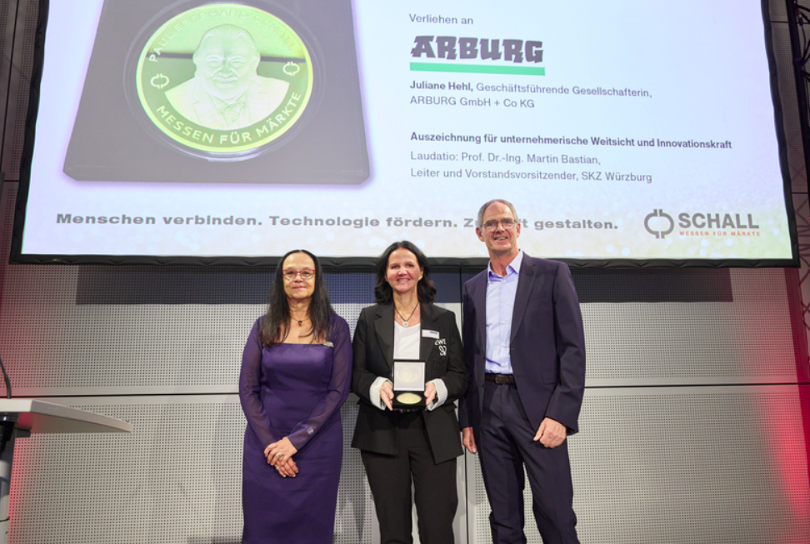

30th Fakuma: In recognition of 45 years of support, from the company’s foundation in 1981 to today’s important European plastics trade fair, Arburg’s Managing Partner Juliane Hehl (centre) received the first Paul Eberhard Schall Medal from Bettina Schall, Managing Director of the trade fair organiser P. E. Schall, and the laudator, Prof Dr Martin Bastian, Chairman of the Board of the SKZ Plastics Centre, on 12 October 2026.

Overview TREND Fakuma 2026 DE_D1A6075

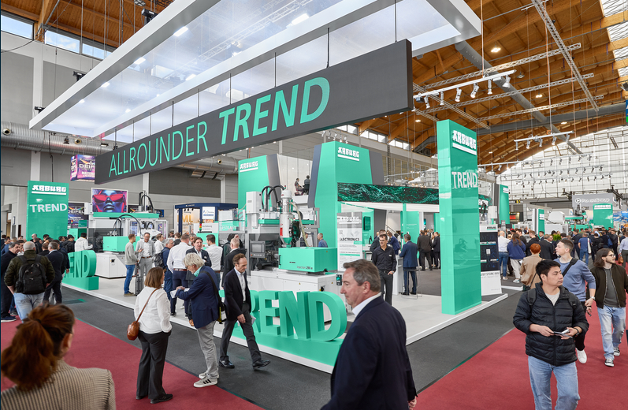

Great interest: The Arburg stand at Fakuma 2026, with its special “Allrounder Trend” area and its focus on the Smartest Factory, was a real crowd-puller.

Smartest Factory Fakuma 2026 DE_D1A5719

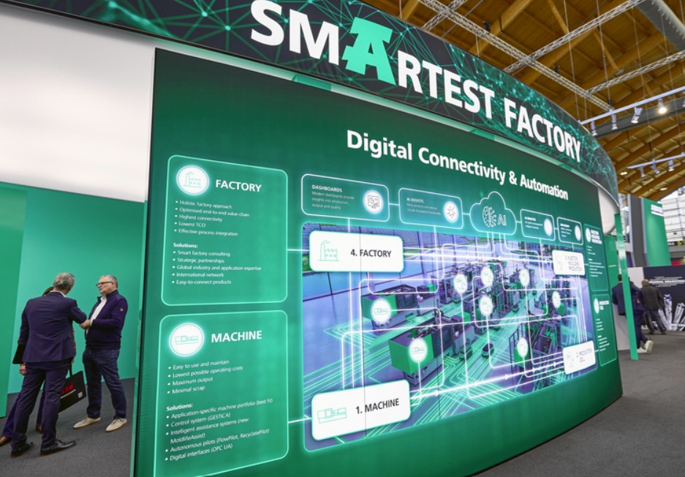

Smartest Factory: At Fakuma 2026, Arburg used a maturity model to demonstrate to customers and prospective clients how they can use digitalisation and automation to make processes more efficient and to reduce unit costs – from individual injection moulding machines right through to the entire factory.

Overview of standalone robots at Fakuma 2026 _DE_D1A5770

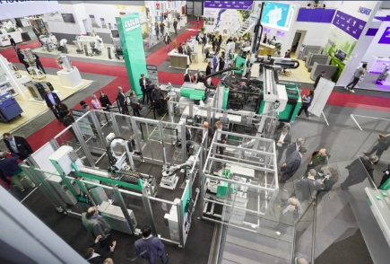

Premiere at Fakuma 2026: Three robots in the new standalone version assembled boxes. These were fed into a production cell centred around an Allrounder More 2000 and completed to form a ready-to-use domino set.

Apprentices at Career Friday Fakuma 2026 DE_IMG_3915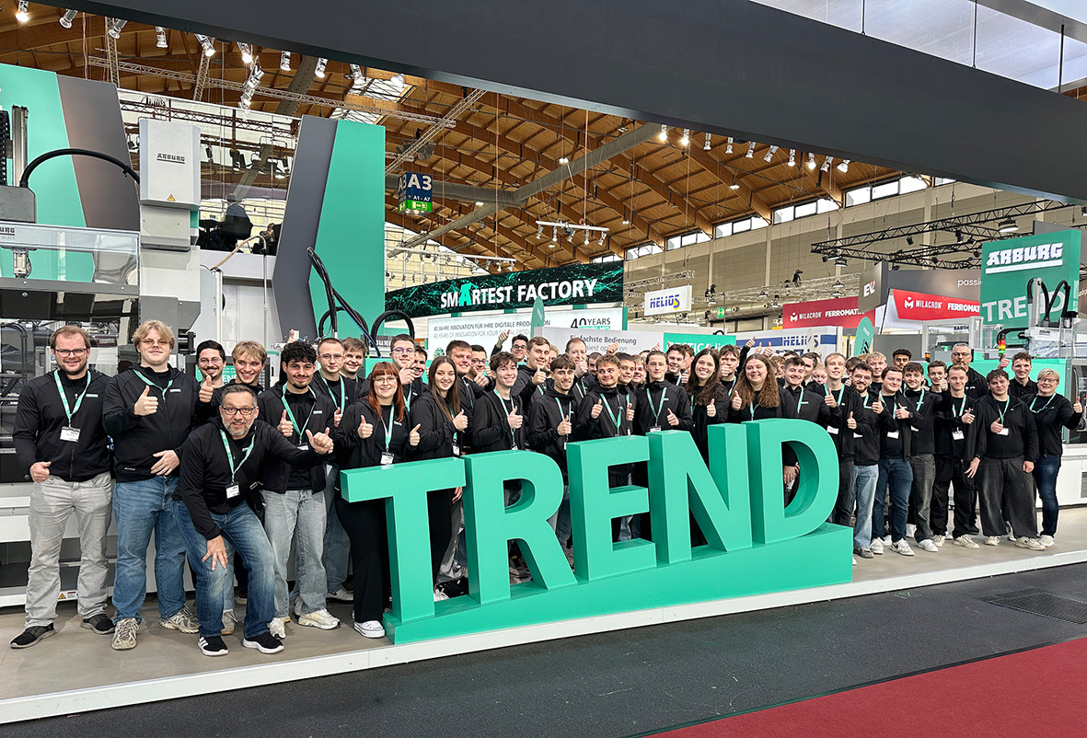

With great passion: at the Fakuma 2026 Career Friday event, apprentices and trainers at the Arburg stand highlighted the diverse career opportunities available at this innovative company.

STORK IMM Fakuma 2026 DE_M1A1835

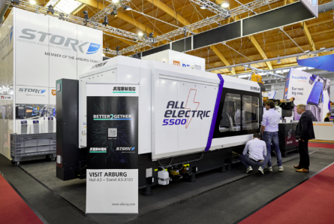 New member of the Arburg family: Stork IMM presented an fully electric All-Electric 5500 for the packaging industry at its stand. Using a 2-cavity mould, this high-performance machine produced IML containers, each with a capacity of around four litres, in a cycle time of just 4,8 seconds.

Photos: Arburg

Photo download:
https://media.arburg.com/web/d6f287c9fa4163a7/fakuma-2026-press-review/

Press release
File: ARBURG press review Fakuma 2026_en_GB.docx
Characters: 8,368
Words: 1,268

This and other press releases are available for download from our website at www.arburg.com/de/presse/ (www.arburg.com/en/press/)

Contact
ARBURG GmbH + Co KG
Press office
Susanne Palm
Dr Bettina Keck
Postfach 1109
72286 Lossburg, Germany
Tel.: +49 (0)7446 33-3463
Tel.: +49 (0)7446 33-3259
presse_service@arburg.com

About Arburg
Founded in 1923, the German family-owned company is one of the world's leading manufacturers of injection moulding machines. AMKmotion, a manufacturer of electric drive technology, also belongs to the Arburg family.
The portfolio for plastics processing encompasses Allrounder injection moulding machines, robot systems as well as customer- and industry-specific turnkey solutions. It also includes digital products and services. Arburg is a pioneer in the plastics industry when it comes to energy and production efficiency, digitalisation and sustainability. Arburg machines are used to manufacture plastic products for the mobility, packaging, electronics, medical, construction and equipment engineering and leisure industries, for example.
The company headquarters are located in Lossburg, Germany. In addition, Arburg has own organisations in 27 countries at 37 locations and is represented in over 100 countries together with trading partners. Of a total of roughly 3,300 employees, about 2,700 work in Germany, with another 600 employees based in Arburg's organisations around the world.
Arburg is certified to ISO 9001 (Quality), ISO 14001 (Environment), ISO 27001 (Information Security), ISO 29993 (Education and Training) and ISO 50001 (Energy).
Further information: www.arburg.com, www.amk-motion.com.

