Juniális: Arburg Hungary’s early summer event
Laszlo Csizmadi, Managing Director of Arburg Hungary, on the success of Juniális 2026

Lossburg, 24/06/2026
On 17 and 18 June 2026, the traditional Juniális event took place at Arburg’s Hungarian subsidiary in Budapest. The highlight was the market launch and live presentation of the new electric Allrounder Trend in Hungary. The event also focused on the topics of automation, digitalisation and energy efficiency. In an interview, Laszlo Csizmadi, Managing Director of Arburg Hungária Kft., explains why this event, which attracted well over 100 participants, wa ssuch a resounding success for everyone.

What was particularly well received at Juniális 2026?
We are delighted with Juniális, which has established itself as an excellent platform for professional dialogue. This year, the market launch of our Allrounder Trend, an entire new product development, imbued this event with a very special significance. With these standard electric machines, we aim to grow strongly in our market while also attracting entirely new customers. Furthermore, , in a practical manner, we showcased Arburg’s broad portfolio of products and services, as well as our expertise in the fields of automation and digitalisation, demonstrating that our solutions are precisely tailored to market requirements.

What added value do these new standard machines offer?
The Allrounder Trend meets our customers’ requirements for all-electric, technologically advanced machines for standard applications. Also, these machines are available quickly and at an attractive price. The Gestica lite control system – also new and remarkably simple and intuitive to use – was particularly well received by younger operators. It adopts the logic and operational philosophy familiar from Arburg control systems, augmenting these with ‘smart’ functions and active support.

Which exhibits were on display?
As an example of our automation expertise, we demonstrated the fully automatic production of model dolphins on an electric Allrounder 1000 e Trend. Handling was performe by a Multilift Select 8. A production cell centred around a hybrid Allrounder 470 H was also equipped with a linear robot system, producing thin-walled lids. Here, we demonstrated the Cavity Eye sensor technology as well as connection via OPC UA. The third exhibit, a hydraulic Allrounder 420 C, produced 500-ml polycarbonate cups.

How did the interplay between theory and practice go?
Everyone involved gave their all, and this went down really well with the guests. We were supported by Polarform and Slezák (tools), Cavity Eye (sensor system) and Prim-Plast (peripheral devices). In addition, the partners gave short presentations: Polarform addressed the current challenges in mould technology, Prim-Plast introduced new cooling systems, and Cavity Eye demonstrated how sensors can be used to measure mould cavity pressure in real time in order to monitor the filling process and holding pressure and reduce scrap. Furthermore, experts from Arburg’s German central headquarters in Lossburg made a significant contribution to the event’s high technical standard with their in-depth, practical presentations on the Allrounder Trend and Gestica lite. This enabled us to clearly demonstrate that, by pooling our expertise, we are able to provide our customers with comprehensive support- This helps them to overcome the challenges they face in their day-to-day injection moulding operations as effectively as possible and to implement the solutions that make the most sense and that are the most cost-effective for them.

What makes Arburg particularly attractive to its customers?
Juniális has once again impressively demonstrated just how important practical demonstrations and face-to-face dialogue are – especially when introducing new technologies. However, we showcased far more than ‘just’ machines. Instead, we support our customers every step of the way – from the initial product concept, through consultancy on application and mould technology, right through to after-sales service – offering complete solutions from a single source. We are highly proactive in both sales and service to ensure that production operations remain stable. This also extends to optimising existing customer machinery, implementing necessary adjustments and assuring reliable production over the long term.

What was the customer feedback like?
Participants greatly appreciated being able to see for themselves, first-hand, the performance and benefits of the new standard electric machines, including their control systems. They were particularly impressed by the ease of operation and maintenance, as well as by the quick and straightforward setup process. Many of our customers, for example in the automotive industry, are struggling with a shortage of skilled workers and an uncertain order situation and are under significant cost and price pressure. The response to our cost-effective Allrounder Trend machines, which are available at short lead times, was correspondingly positive. We were also able to provide clear impetus regarding how to leverage the full potential of automation and digitalisation, and, in face-to-face discussions, to advise on how we can help our customers prepare for the future, step by step.

What is your personal conclusion
In my view, Juniális 2026 was a resounding success. Our customers and prospective clients confirmed that they have a clear interest in and a genuine need to experience innovations first-hand. We demonstrated that Arburg, as a full spectrum provider of injection moulding machines, automation and digital products and services, fulfils the desire for cost-effective, easy-to-implement solutions that deliver tangible benefits swiftly. Events such as these provide valuable impetus and help to inspire and motivate our customers in their own development efforts. The very favourable feedback we receivedencourages us to continue along this path consistently and to continue offering targeted knowledge exchange, innovation and collaborative partnerships now and into the future.

Images

Juniális Laszlo Csizmadi 2026 HU_02-315

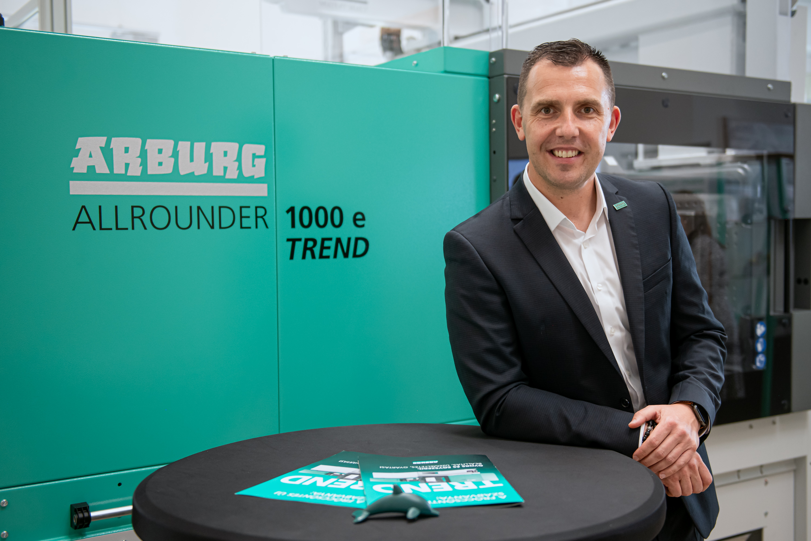

At the official market launch in Hungary, Managing Director Laszlo Csizmadi presented the new Allrounder Trend standard machines as the highlight of the event to customers and prospective clients at Juniális 2026 in Budapest.

Juniális előadás 2026 HU_01-136

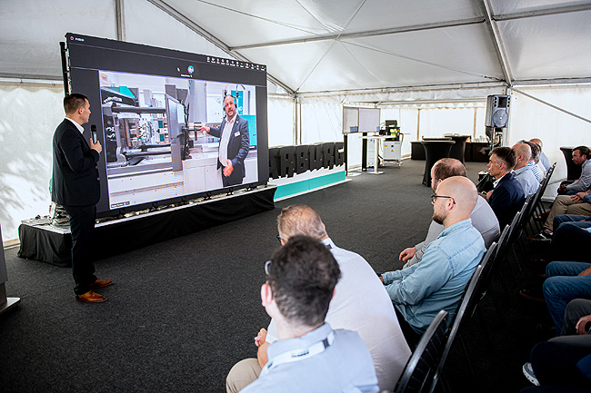

Guests at Juniális 2026 were delighted to get a first-hand look at the new electric Allrounder Trend machines, both in person and through specialist presentations.

Photos: ARBURG
Photo download:
https://media.arburg.com/web/55c5927793eafe94/junialis-2026-press-review/

Press release
File: ARBURG press review interview Junialis 2026_en.docx
Characters: 5,941
Words: 875

This and other press releases are available for download from our website at www.arburg.com/de/presse/ (www.arburg.com/en/press/)

Contact
ARBURG GmbH + Co KG
Press office
Susanne Palm
Dr Bettina Keck
Postfach 1109
72286 Lossburg, Germany
Tel.: +49 (0)7446 33-3463
Tel.: +49 (0)7446 33-3259
presse_service@arburg.com

About Arburg
Founded in 1923, the German family-owned company is one of the world's leading manufacturers of injection moulding machines. AMKmotion, a manufacturer of electric drive technology, also belongs to the Arburg family.
The portfolio for plastics processing encompasses Allrounder injection moulding machines, robot systems as well as customer- and industry-specific turnkey solutions. It also includes digital products and services. Arburg is a pioneer in the plastics industry when it comes to energy and production efficiency, digitalisation and sustainability. Arburg machines are used to manufacture plastic products for the mobility, packaging, electronics, medical, construction and equipment engineering and leisure industries, for example.
The company headquarters are located in Lossburg, Germany. In addition, Arburg has own organisations in 27 countries at 37 locations and is represented in over 100 countries together with trading partners. Of a total of roughly 3,400 employees, about 2,800 work in Germany, with another 600 employees based in Arburg's organisations around the world.
Arburg is certified to ISO 9001 (Quality), ISO 14001 (Environment), ISO 27001 (Information Security), ISO 29993 (Education and Training) and ISO 50001 (Energy).
Further information: www.arburg.com, www.amk-motion.com.

