Arburg Technology Days 2026
The leading information platform for all plastics processors

- A success: The industry’s largest in-house event worldwide, attracting around 3,750 visitors
- arburgSOLUTIONworld: Practical solutions, high performance and 40 machine exhibits
- Highlight: New electric Allrounder Trend machines receive an enormous response

Lossburg, 16/03/2026
Around 3,750 visitors from 44 countries attended the Arburg Technology Days from 11 to 13 March 2026, dedicated entirely to arburgSOLUTIONworld. This industry highlight once again impressed with its tried-and-tested concept of opening the doors of Arburg’s central headquarters in Lossburg to its German and international customers. With more than 40 machine exhibits and a wide range of practical applications, innovative processes, smart automation, as well as digital services, software and after-sales offerings, Arburg demonstrated its capabilities in every respect – from standard to high-end. The company presented itself across the entire value chain as an innovative solution provider and as a competent and reliable partner.

The guests were thoroughly delighted to learn more about the present and future of injection moulding – from the new electric Allrounders Trend through special exhibition areas dedicated to medical technology, sustainability, automation and turnkey solutions, to specialist presentations, a comprehensive service area and insights into the state-of-the-art assembly line for the Trend machines. There was also ample opportunity for networking and for one-on-one discussions with the experts from Arburg and its partners.

Once again, unique for the entire industry
“Presenting the wide range of solutions – the unique blend of technology, processes and services – all in one place makes the Arburg Technology Days the ‘home of injection moulding’, a showcase for plastics processing and a magnet for customers from all over the world”, summarised Juliane Hehl, Managing Partner Global Marketing and Business Development at Arburg. “Nowhere else is such a wealth of information concentrated in such a customer-focused way. We see ourselves as a highly reliable partner who cultivates the best possible business relationships over the long term. With us, everyone finds exactly the right answers to their individual injection moulding questions of today and tomorrow. We had many fruitful discussions and received substantive enquiries about our machines, services and solutions”.
Dr Christoph Schumacher, Vice President Global Marketing, adds: “These Technology Days are a fixture in the trade fair calendars of our customers and prospective clients. The high level of commitment and customer focus shown by each and every one of us leaves an extremely positive overall impression. This makes a visit to the Technology Days an experience within and alongside the Arburg family.”

Hands-on experience: Allrounder Trend highlight
Five exhibits of the electric Allrounder Trend demonstrated how rapid set-up and simple operation enable the efficient production of plastic parts. The new standard machines are available worldwide. At the market launch in spring 2026, four machine sizes with clamping forces ranging from 500 to 2,000 kN will be available. The following exhibits could be experienced live:
- A typical application for technical injection moulding was the production of free-falling, angled insulators for automotive wiring harnesses on an electric Allrounder 1000 e Trend.
- An automated Allrounder 1000 e Trend attracted a great deal of attention as it produced the “Donut-ella” – a practical USB cable winder – from PA material recycled from abandoned fishing nets. The gadget was the winner of the Italian “Pleiades” design competition of the IUAV University of Venice. Arburg supports this competition with machine technology; other partners include Uniform (mould) and Ewikon (hot runner).
- An electric Allrounder 500 e Trend produced reusable coffee cups made from coffee grounds. The bio-based compound and tool for this came from the Danish start-up Grounded.
- The efficient production of 9,200 LSR closures per hour was demonstrated on a production cell centred around an Allrounder 1800 e Trend with a 64-cavity tool from ACH Solution and a linear Multilift Select 16.
- The new Gestica lite control system for the Allrounder Trend also attracted enormous interest from visitors. It is simple and intuitive to use and features a clear, centralised dashboard that is easy to understand. This makes the machine much easier to oerate, even for non-specialists.

Automation and turnkey solutions take centre stage
Skills shortages and labour costs are increasingly pointing a spotlight at customised automation and turnkey projects into focus. Arburg sees itself in every respect as a “problem solver”, finding turnkey solutions that keep unit costs to a minimum without compromising maximum quality in any way. The turnkey experts offer expertise tailored to the specific case of application and support the customers throughout the entire value chain, from the initial idea to the finished product. Several customer projects and Arburg exhibits demonstrated succinctly, how ingenious ideas and efficient automation can be put into practice.
To showcase this, e. g. a turnkey system centred around a vertical Allrounder 475 V produced covers for radio keys as an example. Here, overmoulding with PC/ABS recycled material combined with in-mould decoration (IMD) creates a high-quality surface. Part handling and re-working are carried out by a Kuka six-axis robot integrated into the Gestica control system.

Focus on Medical: Diverse clean room solutions
Arburg had set up a dedicated “Medical Corner” for the expanding medical sector. This showcased some pioneering exhibits from the field of medical technology – developed by Arburg and renowned partners: stand-alone solutions, a production cell docked to a clean room, and production directly within that clean room – an appropriate concept to meet every requirement.
- One benchmark project is the digitally interlinked turnkey system for injector pens, the “NextGen Medical Solution”, centred around an Allrounder 570 A electric machine in cleanroom version. This production cell was realised through the collaboration of Arburg (machine technology), Hack Formenbau (mould technology), Hack Digital Solutions (mould monitoring), HB-Therm (temperature control units) and a renowned OEM. It impresses with a holistically optimised, cost-effective, compact configuration characterised by high availability, productivity, part quality and energy-efficiency.
- An Allrounder 370 A electric injection moulding machine demonstrated how medical products can be manufactured in an ISO Class 7 clean room under the most stringent of hygiene standards. The dual-cavity pilot mould from partner Fostag can be scaled up to a large number of mould cavities once the part design has been finalised.
- A cost-effective investment is to connect a clean room-rated machine to the clean room via an extended tunnel conveyor belt. This was demonstrated on an electric Allrounder 520 A. Using a 96-cavity tool from partner Kebo, around 60,000 needle caps for insulin pens made from PP (Borealis) were produced per hour. These were then fed into the clean room on an enclosed conveyor belt.
- Using a demo part for microfluidics, a hydraulic Allrounder 520 S demonstrated, a simple, reliable and cost-effective way of manufacturing medical products from PVC, known as a difficult material to process.
- Is there a reliable process for achieving shot weights of just 0.016 grams? This is precisely what a production cell based around an electric Allrounder 270 A set out to demonstrate. The machine was equipped with a size 5 micro injection module and an 8-millimetre injection screw and it showcased the sprueless production of four micro-filters, each weighing 0.004 grams and featuring complex geometries.

High levels of public interest across the board
Other key areas of the Arburg program also proved very popular with visitors. Considerable interest was shown in digital services and software across the entire value chain. Many of these solutions enable customers to minimise their operating costs and thus save money. Here, Arburg provides support with its combined expertise in digitalisation, smart manufacturing and artificial intelligence. The Gestica lite control system, Arburg’s own MES (ALS) and the arburgXworld customer portal were presented. In addition, the added value of innovative digital pilots and assistants was demonstrated on Allrounder exhibits.
In the arburgGREENworld exhibition area, the company demonstrated what it has to offer in terms of processing recycled materials and alternative plastics, as well as the activities contributing to resource conservation and the implementation of a functioning circular economy.
The wide range of Application Technology services was also showcased, including on-site consultancy, fault analysis and process optimisation. In the service area, the range of services covering the entire machine lifecycle was on display. Here too, the focus was on ‘ease of use’. These machines are easy to operate and maintain. This enables even relatively inexperienced operators to manufacture products of the highest quality. The maintenance of the new Allrounder Trend, predictive maintenance, comprehensive after-sales support and Ready2Go used machines, as well as modern training methods, were demonstrated.
The technical presentations on all three Technology Days were complemented by interesting expert talks. These offered practical insights – from reliable injection moulding and the path to the Smart Factory right through to the latest Allrounder Trend machines. And last but not least, the factory tours were also very well received. Among other things, interested visitors were able to find out in detail about the new Allrounder Trend production concept and gain interesting insights into the highly automated production at Arburg.

Images

TREND area TD 2026 DE_DSC1726

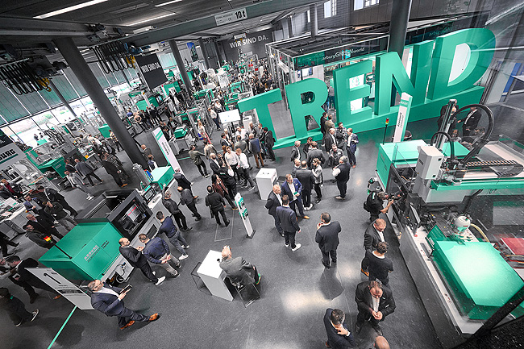

A highlight among the approximately 40 machine exhibits at the Arburg Technology Days 2026 was the electric Allrounder Trend – defining a new standard in injection moulding

Donut-ella TD 2026 DE_D1A3667

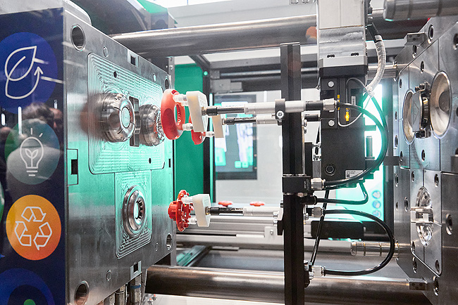

A new standard Allrounder 1000 e Trend machine produced the “Donut-ella” – a USB cable winder and a design product much sought after by visitors – at the Technology Days 2026.

Digitalisation TD 2026 DE_DSC1780

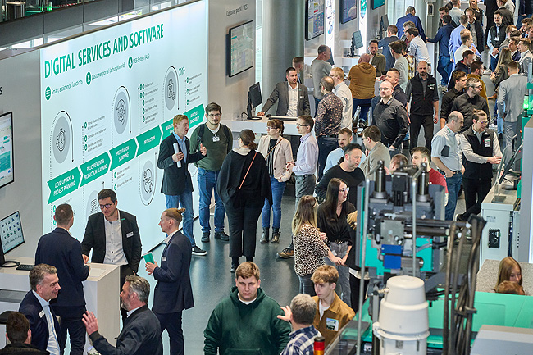

Digitalisation is a key topic for many customers. In a large exhibition area, Arburg presented the arburgXworld customer portal, Arburg’s own MES, Gestica control systems and Allrounder exhibits featuring smart pilot and assistance functions.

TREND Service TD 2026 DE_D1A3926

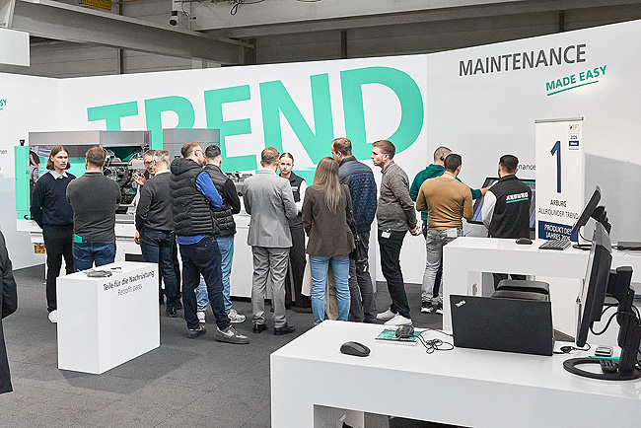

Detailed information on easy maintenance, modern training courses and useful facts about the service support for the new Trend machines was available at the Technology Days 2026.

Turnkey_TD 2026 DE_DSC1807

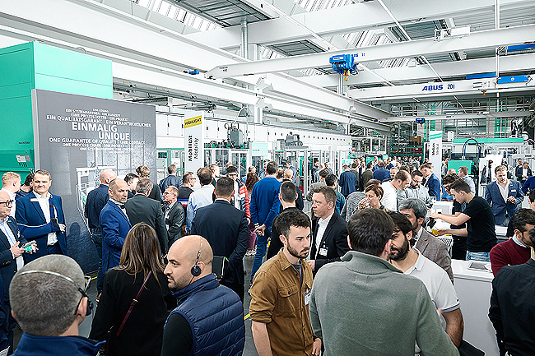

The Automation and Turnkey section attracted considerable interest, with Arburg presenting its portfolio of robotic systems as well as complex production cells and customer projects.

Photos: ARBURG
Photo download:
https://media.arburg.com/web/7885eaf65090781c/press-review-ARBURG technology days 2026/

Press release
File: Press release Technology Days 2026_en.docx
Characters: 9,661
Words: 1,433

This and other press releases are also available for download on our website at www.arburg.com/de/presse/ (www.arburg.com/en/presse/).

Contact
ARBURG GmbH + Co KG
Press office
Susanne Palm
Dr Bettina Keck
Postfach 1109
72286 Lossburg, Germany
Tel.: +49 (0)7446 33-3463
Tel.: +49 (0)7446 33-3259
presse_service@arburg.com

About Arburg
Founded in 1923, the German family-owned company is one of the world's leading manufacturers of injection moulding machines. AMKmotion, a manufacturer of electric drive technology, also belongs to the Arburg family.
The portfolio for plastics processing encompasses Allrounder injection moulding machines, robot systems as well as customer- and industry-specific turnkey solutions. It also includes digital products and services. Arburg is a pioneer in the plastics industry when it comes to energy and production efficiency, digitalisation and sustainability. Arburg machines are used to manufacture plastic products for the mobility, packaging, electronics, medical, construction and equipment engineering and leisure industries, for example.
The company headquarters are located in Lossburg, Germany. In addition, Arburg has own organisations in 27 countries at 37 locations and is represented in over 100 countries together with trading partners. Of a total of roughly 3,400 employees, about 2,800 work in Germany, with another 600 employees based in Arburg's organisations around the world.
Arburg is certified to ISO 9001 (Quality), ISO 14001 (Environment), ISO 27001 (Information Security), ISO 29993 (Education and Training) and ISO 50001 (Energy).
Further information: www.arburg.com, www.amk-motion.com

