Arburg at FIP 2026 in Lyon
Arburg brings technology and customer requirements together

- Premiere: Automated Allrounder Trend makes its French debut
- Important: Customised solutions are in demand
- Digitalisation: Topic takes centre stage

Lossburg, 02/04/2026
From 2 to 5 June 2026, FIP (France Innovation Plasturgie) will once again open its doors to trade visitors in Lyon. Arburg is placing particular emphasis on France, the country where its first international subsidiary was established. Making its debut at stand K16-L03 this year is a new standard machine, the Allrounder Trend, featuring the equally new Gestica lite control system. Another focus is on the topic of digitalisation, with presentations including Arburg’s own MES (ALS) and the arburgXworld customer portal with its numerous apps.

Pascal Laborde, Managing Director of Arburg SAS, emphasises the importance of FIP: “This trade fair is of particular significance for the plastics industry in France, since the entire sector is represented here. We are currently facing considerable industry-wide challenges. Customers are increasingly looking for machines for standardised products that are easy to operate and maintain, while also in equal measure seeking value for money and energy efficiency. The circular economy is also an important issue. We are convinced that with our new standard machine, the Allrounder Trend, and its intuitive, easy-to-use Gestica lite control system, we are very well positioned to address these challenges”.

Short delivery times, excellent value
The electric Allrounder Trend machines are suitable for standard applications across all industries and are available worldwide. They can be set up remarkably quickly, they are intuitive to operate, easy to maintain and they offer low investment and operating costs. At launch, four machine sizes with clamping forces ranging from 500 to 2,000 kN will be available. All Trend machines are equipped with the new Gestica lite control system. This features an intuitive user interface and a clearly laid out dashboard.
At the FIP, to demonstrate to visitors how easily and cost-effectively automated production can be achieved with the new Allrounders Trend, they will produce sustainable reusable multifunctional cutlery – combining a cutting edge, a fork and a spoon. The sprue is separated, ground up in a mill and fed directly back into the production process. The electric Allrounder1000 e Trend with a clamping force of 1,000 kN is integrated into a turnkey system featuring a cooler and temperature control unit as well as a Thermolift. A Multilift Select 4 linear robotic system operates the injection-moulded parts made from PBT (GF30) containing around one-third PCR. The 4-cavity mould is supplied by Arburg partner FairCup. The cycle time is around 60 seconds, and the part weight is around 79 grams.

Boosting efficiency with digital products and service support
When it comes to digitalisation, Arburg also supports its customers with its one-top shop of expertise, smart manufacturing and artificial intelligence. Among the products to be showcased at FIP 2026 are, for example, the Gestica lite control system with innovative digital pilots and assistants, Arburg’s own Manufacturing Execution System (ALS) and the arburgXworld customer portal.
One example of the many features available in Gestica lite is the ‘aXw Control RecyclatePilot’. This actively compensates for material fluctuations. Via ALS, for example, all information on orders, production progress, set-up times and maintenance can be retrieved and archived. The associated data sets can be transferred automatically to the injection moulding machine.
Using the tools in arburgXworld, users can configure Allrounder machines, retrieve information about machines or order spare parts – supported with AI, 24 hours a day, seven days a week. The AI-powered ‘Ask Arburg’ app is also particularly helpful in this context; it contains a wealth of easily accessible injection moulding knowledge and can answer specific questions about all Arburg products and processes relating to injection moulding, as well as analyse faults.

Exhibits tailored to customer requirements
Pascal Laborde is certain: “Our bespoke offering ranges from machines with specific peripheral equipment and digital solutions to boost production efficiency, right through to reliable after-sales services, as well as training and consultancy services. This means our exhibits at FIP are perfectly tailored to our customers’ current requirements”.

Images

ALLROUNDER 1000e TREND 290e_003

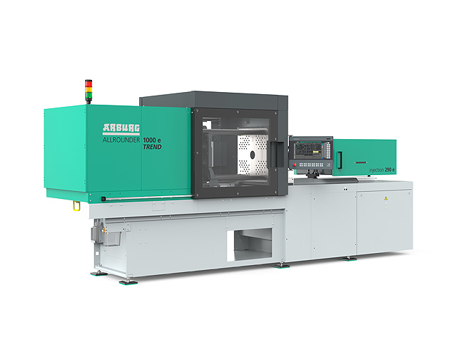

The new Allrounder Trend have a specific configuration that meets current market needs: They are available at short notice, they can be set up quickly, are remarkably easy to operate and maintain, and are characterised by low investment and operating costs.

Cutlery Faircup_DSC1674

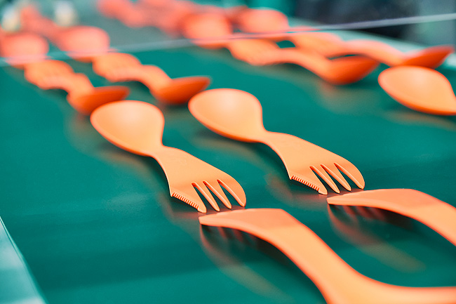

At FIP 2026, an electric Allrounder 1000 e Trend is automatically producing reusable multifunctional cutlery.

Pascal Laborde_DSC7212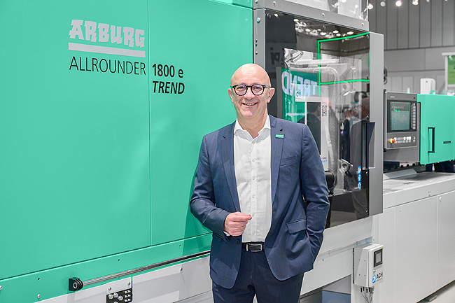

Pascal Laborde, Managing Director of Arburg SAS, Tremblay-en-France, France.

Photos: ARBURG
Photo download:
https://media.arburg.com/web/ccf9029fc800e9e4/fip-2026-press-preview/

Press release
File: ARBURG press release FIP 2026_en_GB.docx
Characters: 4,266
Words: 642

This and other press releases are also available for download on our website at www.arburg.com/de/presse/ (www.arburg.com/en/presse/).

Contact
ARBURG GmbH + Co KG
Press Office
Susanne Palm
Dr Bettina Keck
P.O. Box 1109
72286 Lossburg, Germany
Tel.: +49 7446 33-3463
Tel.: +49 7446 33-3259
presse_service@arburg.com

About Arburg
Founded in 1923, the German family-owned company is one of the world's leading manufacturers of injection moulding machines. AMKmotion, a manufacturer of electric drive technology, also belongs to the Arburg family.
The portfolio for plastics processing encompasses Allrounder injection moulding machines, robot systems as well as customer- and industry-specific turnkey solutions. It also includes digital products and services. Arburg is a pioneer in the plastics industry when it comes to energy and production efficiency, digitalisation and sustainability. Arburg machines are used to manufacture plastic products for the mobility, packaging, electronics, medical, construction and equipment engineering and leisure industries, for example.
The company headquarters are located in Lossburg, Germany. In addition, Arburg has own organisations in 27 countries at 37 locations and is represented in over 100 countries together with trading partners. Of a total of roughly 3,400 employees, about 2,800 work in Germany, with another 600 employees based in Arburg's organisations around the world.
Arburg is certified to ISO 9001 (Quality), ISO 14001 (Environment), ISO 27001 (Information Security), ISO 29993 (Education and Training) and ISO 50001 (Energy).
Further information: www.arburg.com, www.amk-motion.com.

