Arburg at Interplas 2026
Pioneering trends for the British and Irish plastics industry

- Focus: Two Allrounder Trend machines demonstrate what is possible with standard machines
- Service: Arburg Ltd. impresses with comprehensive services for the UK and Ireland
- Show: An important network opportunity for Arburg to connect with customers and partners

Lossburg, 09/04/2026
From 2 to 4 June 2026, Arburg (Hall 10, Stand L50) will be presenting two electric Allrounder Trend at Interplas in Birmingham. This marks the first time Arburg’s new standard machines will be on show to a large trade visitor audience in the UK. The trade fair presentation will be accompanied by detailed information on automation, digitalisation and sustainability, areas in which Arburg plays a leading role as an industry pioneer.

“These energy-efficient electric Allrounder Trend machines take pride of place in our trade fair presentation. They are arriving in the UK and Ireland at exactly the right time, a time when energy costs are rising continuously”, states Steve Thomson with conviction. He has been Managing Director of Arburg Ltd. since December 2025. “We are also seeing considerable interest in automation. We are showcasing interesting solutions in this area, and our turnkey experts will be happy to answer individual questions from customers and prospective clients”.

Allrounder Trend: Short delivery times, excellent value
The electric Allrounder Trend machines are suitable for standard applications across all industries and delivery times are short, for anywhere in the world. These machines are remarkably quick to set up, they are intuitive to operate and easy to maintain. Their low investment and operating costs are impressive. Their high energy efficiency class 8+ (Euromap 60.1) boosts their profitability on a daily basis in injection moulding plants. At market launch, there will be four sizes with clamping forces ranging from 500 to 2,000 kN. All Trend machines are equipped with the new Gestica lite control system. This features an intuitive user interface and a well laid out dashboard.

Exhibits: Focus on automation and sustainability
At Interplas 2026, sustainability continues to be an important topic for Arburg. This will be demonstrated live with an electric Allrounder 500 e Trend with a clamping force of 500 kN and partner Symbiotex, a manufacturer of high-performance biomaterials for injection moulding. Arburg will be producing a biodegradable golf tee made from ‘ThermoSea’ material, which uses sustainably cultivated red seaweed as a feedstock – making it 100% certified bio-based, and certified home compostable at its end of life – without compromising the performance or efficiency moulders need.
The second exhibit, an electric Allrounder 1000 e Trend with a clamping force of 1,000 kN will be producing reusable closure clips for food bags. A linear robotic system Multilift Select 8 will be used to operate the process automatically.

Another key focus: digitalisation
Digitalisation will also play an important role at Interplas 2026, alongside the launch of the new Allrounder Trend. The arburgXworld customer portal with its numerous helpful apps, Arburg’s own MES (ALS) and the Arburg Remote Service (ARS) will all be presented on screens in a practical manner, enabling trade fair visitors to view the benefits for themselves. For example, with the arburgXworld customer portal, users can configure Allrounders, retrieve information on machines or order spare parts – all with AI-support, 24 hours a day, seven days a week. The Gestica lite control system, with its intuitive user interface and clearly laid out dashboard, making operation a breeze even for non-specialists. Gestica lite is equipped with an extensive range of assistance functions. Added to this are simplified navigation and search with AI functionality, as well as the ability to troubleshoot quickly thanks to assisted work procedures.

Interplas: A key platform for networking
Steve Thomson is confident that the portfolio on display at Interplas is exactly what customers in the UK and Ireland currently need: “We are particularly keen to connect with customers who, thanks to our new Allrounders, are ready to make the move to all-electric machines. We also offer our usual high level of user-friendliness, automation, and above all, high performance, quality and service at a great price. Everything is just right here”.

Images

ALLROUNDER 1000e TREND 290e_003

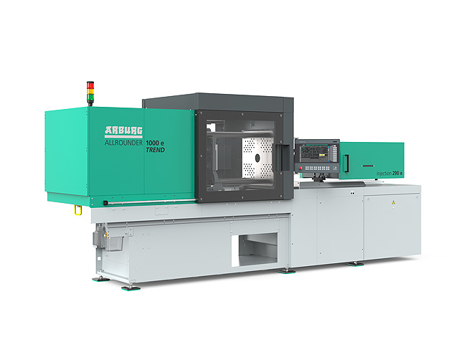

The new Allrounder Trend are specifically configured to meet current market needs: They are available at short notice, they can be set up quickly, are remarkably easy to operate and maintain, and the costs of investment and operation are low.

ALLROUNDER 1800 e TREND_397

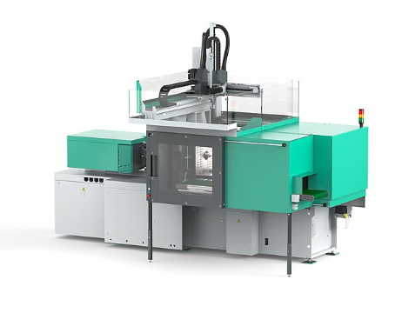

The Allrounder Trend machines can be equipped with all Arburg robotic systems.

Steve Thomson_J0A0137

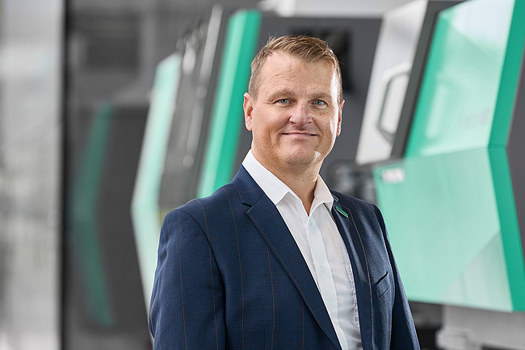

Steve Thomson, Managing Director of Arburg Ltd. in Warwick, UK.

Photos: ARBURG
Photo download:
https://media.arburg.com/web/a4a21988f9cc308c/interplas-2026-press-preview/

Press release
File: ARBURG press preview Interplas 2026_en_GB.docx
Characters: 4,046
Words: 627

This and other press releases are also available for download on our website at www.arburg.com/de/presse/ (www.arburg.com/en/presse/).

Contact
ARBURG GmbH + Co KG
Press Office
Susanne Palm
Dr Bettina Keck
P.O. Box 1109
72286 Lossburg, Germany
Tel.: +49 7446 33-3463
Tel.: +49 7446 33-3259
presse_service@arburg.com

About Arburg
Founded in 1923, the German family-owned company is one of the world's leading manufacturers of injection moulding machines. AMKmotion, a manufacturer of electric drive technology, also belongs to the Arburg family.
The portfolio for plastics processing encompasses Allrounder injection moulding machines, robot systems as well as customer- and industry-specific turnkey solutions. It also includes digital products and services. Arburg is a pioneer in the plastics industry when it comes to energy and production efficiency, digitalisation and sustainability. Arburg machines are used to manufacture plastic products for the mobility, packaging, electronics, medical, construction and equipment engineering and leisure industries, for example.
The company headquarters are located in Lossburg, Germany. In addition, Arburg has own organisations in 27 countries at 37 locations and is represented in over 100 countries together with trading partners. Of a total of roughly 3,400 employees, about 2,800 work in Germany, with another 600 employees based in Arburg's organisations around the world.
Arburg is certified to ISO 9001 (Quality), ISO 14001 (Environment), ISO 27001 (Information Security), ISO 29993 (Education and Training) and ISO 50001 (Energy).
Further information: www.arburg.com, www.amk-motion.com.

