Honouring long-standing trading partner Maqtec
Arburg has been present in Colombia
for 25 years

- Silver anniversary of the partnership between Maqtec and Arburg
- Fruitful cooperation in Colombia and other Latin American countries
- Allrounder Trend: Trade fair highlight and new machine to expand the regional market

Lossburg, 08/10/2026
On 22 September 2026, Maqtec had a major cause for celebration: 25 years as an Arburg trading partner in Colombia and also in other Latin American countries. Christoph Kiefer, Director of Central Sales, and Kadir Cengiz, Manager of Direct & Partner Markets, had travelled from Arburg’s German headquarters in Lossburg to Bogotá to celebrate the silver anniversary in the run-up to the Colombiaplast 2026 trade fair. They presented a certificate to Octavio Guzmán Stokoff, General Manager of Maqtec, and his team of 15 in recognition of their long-standing and reliable trading partnership.

Maqtec (www.maqtec.com.co) can look back on a 28-year history of selling and servicing European and US machinery for the plastics industry in Latin America.
For 25 years, the company has acted as the exclusive representative for Arburg injection moulding technology in Colombia, Ecuador, Peru, Venezuela, Honduras, Nicaragua, the Dominican Republic, El Salvador and Panama.

Octavio Guzmán pays tribute to the commercial partnership
Octavio Guzmán Stokoff pays tribute to the 25-year business partnership between Maqtec and Arburg as follows: “We offer expert advice and comprehensive technical support across our business areas, including integrated technical solutions. This has so far impressed not only our partner Arburg, but also our customers in the injection moulding sector”. The decision to enter into this partnership, Guzmán continues, arose from the need to represent a reliable manufacturer of injection moulding machines in the Colombian and Latin American markets, one with a high level of technological expertise and a strong technical after-sales service. “We are now reaping the rewards of this decision to establish this long-term and fruitful collaboration”. The new Trend electric Allrounder machines are a very good fit for the markets in Colombia and Latin America – and form a solid foundation for the further expansion of the partnership with Arburg in the region. This machine was successfully showcased at Colombiaplast 2026.

Speaking at the small celebration held at Maqtec’s headquarters, Christoph Kiefer remarked: “The joint mission of Maqtec and Arburg is to combine high-quality technology, expert on-site service and competitive, cost-effective solutions in order to sustainably develop our position in Colombia and Latin America”. These anniversary celebrations, marking 25 years of partnership, demonstrate that this has been a very successfully collaboration for a great many years.

Image

25 years partnership Maqtec CO 2026_0166

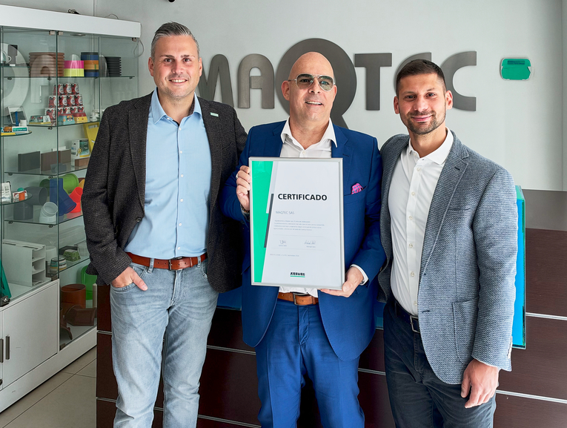

25 years of successful collaboration: At the headquarters of trading partner Maqtec in Bogotá, Colombia, Christoph Kiefer (left) and Kadir Cengiz (right) conveyed greetings from Arburg’s German headquarters in Lossburg and presented Octavio Guzmán Stokoff with an anniversary certificate.

Photo: ARBURG
Photo download:
https://media.arburg.com/web/c6cb7a58ddd0ac82/25-years-maqtec-co-2026_0166/

Press release
File: Pressemitteilung 25 Jahre Maqtec Kolumbien 2026_en_GB.docx
Characters: 2,505
Words: 373

This and other press releases are available for download from our website at www.arburg.com/de/presse/ (www.arburg.com/en/press/)

Contact
ARBURG GmbH + Co KG
Press office
Susanne Palm
Dr Bettina Keck
Postfach 1109
72286 Lossburg, Germany
Tel.: +49 (0)7446 33-3463
Tel.: +49 (0)7446 33-3259
presse_service@arburg.com

About Arburg
Founded in 1923, the German family-owned company is one of the world's leading manufacturers of injection moulding machines. AMKmotion, a manufacturer of electric drive technology, also belongs to the Arburg family.
The portfolio for plastics processing encompasses Allrounder injection moulding machines, robot systems as well as customer- and industry-specific turnkey solutions. It also includes digital products and services. Arburg is a pioneer in the plastics industry when it comes to energy and production efficiency, digitalisation and sustainability. Arburg machines are used to manufacture plastic products for the mobility, packaging, electronics, medical, construction and equipment engineering and leisure industries, for example.
The company headquarters are located in Lossburg, Germany. In addition, Arburg has own organisations in 27 countries at 37 locations and is represented in over 100 countries together with trading partners. Of a total of roughly 3,300 employees, about 2,700 work in Germany, with another 600 employees based in Arburg's organisations around the world.
Arburg is certified to ISO 9001 (Quality), ISO 14001 (Environment), ISO 27001 (Information Security), ISO 29993 (Education and Training) and ISO 50001 (Energy).
Further information: www.arburg.com, www.amk-motion.com.

