Ecovadis Sustainability Award 2026
Arburg sustainable: Gold for sustainability for the fourth time

- One of the best: Arburg ranks among the world’s most sustainable industrial companies
- Continuous improvement: 84 points achieved
- In focus: Machine manufacturer has been committed to the environment and sustainability for decades

Lossburg, 22/10/2026
With a clear focus on sustainability, Arburg received the Ecovadis Gold Medal for the fourth time in October 2026. With this award, the machine manufacturer, headquartered in Lossburg, ranks among the top five per cent of the world’s most sustainable industrial companies. Arburg was assessed across four categories and has improved further compared with the previous year, on this occasion scoring a total of 84 points.

“As a pioneer in the plastics industry, Arburg has been consistently committed to the environment, sustainability and future-proof technologies for decades – even in economically challenging times,” emphasises Arburg Managing Partner Michael Hehl. “The fact that we have satisfied the stringent criteria for the Ecovadis Gold Award for the fourth year running makes us proud and is the outcome of targeted efforts in the areas of production and resource efficiency, the circular economy and social responsibility”, adds Managing Partner Juliane Hehl.

Top five per cent: Transparency and high standards
Ecovadis is a comprehensive sustainability platform for global supply chains. In total, more than 175,000 companies can get assessed across four areas: The environment, sustainable procurement, ethics and labour and human rights.
With 84 out of a possible 100 points, the innovative German family-owned company Arburg, headquartered in Lossburg, ranks among the top five per cent. Since its last Ecovadis award in 2025, Arburg has improved its score in the environmental category, to take just one example, from 89 to 93 points.

Validated climate targets – net-zero emissions by 2050
Since 2019, Arburg has been bringing together all its sustainability initiatives under the arburgGREENworld programme. These include comprehensive measures to improve production and resource efficiency, as well as the circular economy.
As a European manufacturer of injection moulding machines, the company has also set itself validated climate targets in line with the Science Based Targets Initiative (SBTi). Arburg is pursuing ambitious targets to reduce total greenhouse gas emissions and has committed to achieving net-zero emissions across its entire value chain by 2050
Since 2021, Arburg has been calculating its Corporate Carbon Footprint (CCF) annually. As part of the Carbon Disclosure Project (CDP), the company was awarded a ‘B’ rating for its climate management in 2025. This means that Arburg performs above average in terms of climate protection, ecology and CO₂ emissions.
Among other things, a review of the training programme with regard to sustainability was added as part of an LQW audit in February 2026. As a result, Arburg’s training programme is now triple-certified.

Transparent: Data, facts and figures
Relevant data, facts and figures are explained in an easy-to-understand and detailed manner and presented clearly in Arburg’s comprehensive annual sustainability report. This is complemented by a comprehensive analysis, in accordance with the Global Reporting Initiative (GRI), of Arburg’s commitment to environmental, social and economic responsibility. Both can be found on the website:
www.arburg.com/media/daten/other/sustainability-report-2025_de.pdf www.arburg.com/media/daten/other/GRI_Nachhaltigkeitsbericht_2025_de.pdf

Image

Ecovadis Gold 2026_01450

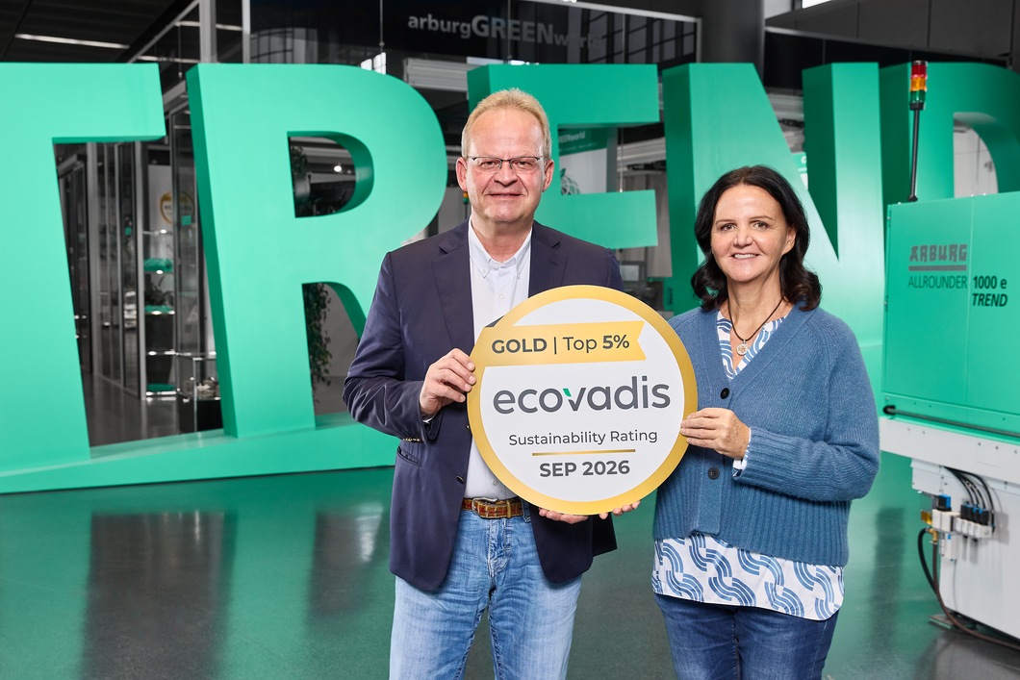

High sustainability standards met: The Managing Partners Juliane and Michael Hehl are proud of the fourth consecutive Ecovadis Gold award, which Arburg received in October 2026.

Photo: Arburg

Photo download:
https://media.arburg.com/web/eb3f239d7123b4ec/ecovadis-gold-award-2026/

Press release
File: ARBURG Pressemitteilung Ecovadis Gold 2026_en_GB.docx
Characters: 3,116
Words: 465

This and other press releases are available for download from our website at www.arburg.com/de/presse/ (www.arburg.com/en/press/)

Contact
ARBURG GmbH + Co KG
Press office
Susanne Palm
Dr Bettina Keck
Postfach 1109
72286 Lossburg, Germany
Tel.: +49 (0)7446 33-3463
Tel.: +49 (0)7446 33-3259
presse_service@arburg.com

About Arburg
Founded in 1923, the German family-owned company is one of the world's leading manufacturers of injection moulding machines. The portfolio for plastics processing encompasses Allrounder injection moulding machines, robotic systems as well as turnkey solutions that are designed customer- and industry-specific. This portfolio also includes digital products and services.
Stork IMM, a manufacturer of large, high-speed injection moulding machines for thin-walled packaging, and AMKmotion, a manufacturer of electric drive technology, also belong to the Arburg family.
Arburg is a pioneer in the plastics industry when it comes to energy and production efficiency, digitalisation and sustainability. Arburg machines are used to manufacture plastic products for sectors such as mobility, packaging, electronics, medical, construction and equipment engineering and leisure industries, for example.
The company headquarters are located in Lossburg, Germany. In addition, Arburg has own organisations in 27 countries at 37 locations and is represented in over 100 countries together with trading partners. Of a total workforce of roughly 3,300 employees, about 2,700 are based in Germany, with the remaining 600 employed in Arburg's organisations around the world.
Arburg is certified to ISO 9001 (Quality), ISO 14001 (Environment), ISO 27001 (Information Security), ISO 29993 (Education and Training) and ISO 50001 (Energy).
Further information: www.arburg.com, www.storkimm.com, www.amk-motion.com.

