Training programme once again triple-certified
Arburg Training programme now also certified for sustainability

- Three certificates: Arburg training programme awarded by ISO 29993, LQW^{N} and IHK
- New: Criteria for German BND and international SDG standards added
- Attractive: Sustainability as a key aspect of training and study at Arburg

Lossburg, 29/04/2026
Apprenticeships at Arburg are and remain outstanding: This is attested to by three certifications in accordance with the requirements of the international standard ISO 29993, Learner and Customer-Oriented Quality Development (LQW), and the regional seal of quality “1A Excellent Training Company” from the North Black Forest Chamber of Industry and Commerce (IHK). As part of an LQW audit, a new certification relating to sustainability was added in February 2026.

“To obtain the LQW^{N} certification, we have fulfilled the criteria of the German-wide BNE (education for sustainable development) programme and also taken into account the United Nations’ ‘Sustainable Development Goals’ (SDG) with their 17 goals for sustainable development,” explains Training Manager Michael Vieth. “This was not difficult for us, as Arburg has long been committed to holistic training, sustainability, and a comprehensive educational approach.”

Sustainability: a key aspect of training
Arburgreceived the new sustainability certification for its training programme as part of the LQW audit for further education organisations. In addition to pedagogical principles, action-oriented learning methods and the development of skills within the training programme, economic, social, environmental and political-institutional aspects of sustainability were also taken into account. Trainer Marius Singer emphasises: “Our training programme is built on a broad foundation. We rely on optimised processes and quantitative indicators of success just as much as on qualitative indicators of success. Added to this is strategic professional development, which ensures that we trainers are equipped with up-to-date knowledge and all the necessary tools to train and support the qualified personnel of tomorrow in line with current requirements.”

Long-standing commitment to sustainability
Arburg trainees regularly take part in projects that contribute to sustainability. For example, their ideas for reducing the company’s carbon footprint have already won them the “Carbon Busters” competition organised by the VDMA, network organization and an important voice for the machinery and equipment manufacturing industry in Europe and Germany, on several occasions. A team of apprentices made their most recent major appearance whilst manning the “arburgGREENworld” pavilion at the world’s leading trade fair, K 2025, in Düsseldorf (Germany), where they provided information on topics including the recycling loop for plastics and Arburg’s resource conservation program. But the trainees also regularly get involved in smaller local actions, such as hanging up nesting boxes on the company premises or collecting litter on the “Black Forest CleanUp Day”, to promote a natural and clean environment.

Successful training at Arburg
To date, the mechanical engineering company has prepared around 2,400 young people for the world of work. This triple certification demonstrates that Arburg is committed to training young people to become qualified personnel and that it meets high national and international standards. Whilst ISO 29993 certifies that the training programmes meet the highest standards and the Chamber of Industry and Commerce (IHK) recognises the company’s support for young talent as going far beyond the requirements, the new LQW^{N} certificate reinforces the aspect of sustainability in training. Yet another reason for career starters to apply to Arburg.
A new cohort of apprentices and DHBW students will start at Arburg in September 2026. A few apprenticeship places are still available in Lossburg for the current year. Interested young people are welcome to find out more and apply for these places, as well as for those in 2027, at www.arburg.com/info/ausbildung.

Image

Training certificate DE_D1A4865

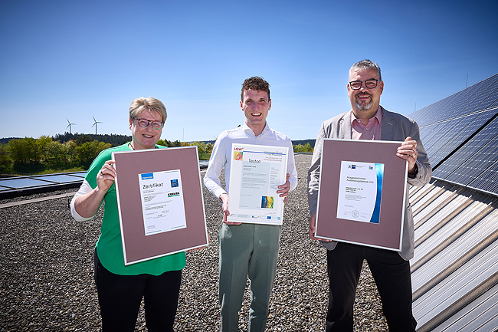

Trainers Isabell Günter and Marius Singer, together with Training Manager Michael Vieth (right), present the three certificates: ISO 29993, LQW^{N} – for the first time incorporating the aspect of sustainability – and the IHK “1A Excellent Training Company” award.

Photo: ARBURG
Photo download:
https://media.arburg.com/web/8df5341108c96c2e/3-fold-certified-training-at-ARBURG-2026/

Press release
File: ARBURG press release certificates training 2026_en_GB.docx
Characters: 3,754
Words: 554

You can also download this and other press releases from our website at www.arburg.com/de/presse/ (www.arburg.com/en/presse/)

Contact
ARBURG GmbH + Co KG
Press Office
Susanne Palm
Dr Bettina Keck
P.O. Box 1109
72286 Lossburg, Germany
Tel.: +49 7446 33-3463
Tel.: +49 7446 33-3259
presse_service@arburg.com

About Arburg
Founded in 1923, the German family-owned company is one of the world's leading manufacturers of injection moulding machines. AMKmotion, a manufacturer of electric drive technology, also belongs to the Arburg family.
The portfolio for plastics processing encompasses Allrounder injection moulding machines, robot systems as well as customer- and industry-specific turnkey solutions. It also includes digital products and services. Arburg is a pioneer in the plastics industry when it comes to energy and production efficiency, digitalisation and sustainability. Arburg machines are used to manufacture plastic products for the mobility, packaging, electronics, medical, construction and equipment engineering and leisure industries, for example.
The company headquarters are located in Lossburg, Germany. In addition, Arburg has own organisations in 27 countries at 37 locations and is represented in over 100 countries together with trading partners. Of a total of roughly 3,400 employees, about 2,800 work in Germany, with another 600 employees based in Arburg's organisations around the world.
Arburg is certified to ISO 9001 (Quality), ISO 14001 (Environment), ISO 27001 (Information Security), ISO 29993 (Education and Training) and ISO 50001 (Energy).
Further information: www.arburg.com, www.amk-motion.com.

