Arburg at Fakuma 2026
World premiere: Standalone robotic systems from Arburg

- Standalone: Arburg automation available without an injection moulding machine for the first time
- Flexible: Handling tasks with a linear Multilift and Yaskawa robots as a standalone solution
- Intuitive: Mobile rControl operating panel for simple and safe programming and operation as usual

Lossburg, 07/10/2026
Arburg’s standalone robot systems are making their debut at Fakuma 2026. These can be used independently of injection moulding machines and are operated very easily, safely and intuitively using the new, standalone ‘rControl’ robot operating panel. This enables customers to scale flexibly when automation is required, to retrofit existing systems and to use them for longer, while at the same time significantly increasing their production efficiency. As an example of flexible automation, a standalone, upstream cell at the Arburg stand 3101 in Hall A3 will demonstrate the interaction of several interlinked robots. These robots assemble folding cartons and pass them on to a production cell that injection-moulds the dominoes.

Arburg’s standalone robots expand the handling options in plastic parts production and offer greater flexibility, especially for upstream and downstream automation tasks such as the preparation of feed parts, assembly and packaging. Standardisation of automation also reduces investment costs. The new standalone solutions will initially be available to customers in Europe from Fakuma 2026 onwards.

Standalone: Can be integrated into existing production lines
Standalone variants are available for the Multilift Select linear robot systems with payloads of 4 to 16 kilograms, as well as for Yaskawa scara and six-axis robots ‘Powered by Arburg’. A Multilift Select as a standalone solution is ideally suited to standard tasks, complemented by a Yaskawa six-axis robot, capable of performing complex handling operations.
The standalone versions of one or more robots can be integrated into new turnkey systems or retrofitted into existing systems, independently of manufacturer, flexibly expanding those systems and extending their service lives. For production cells featuring Allrounders, Arburg is responsible for CE marking; for third-party machines, this is the customer’s responsibility.

New: ‘rControl’ operationg panel for standalone robots
To enable the robots in the standalone version to be programmed and operated independently, they are fitted with an enhanced control cabinet including controller as well as a new mobile control panel which is remarkably compact and lightweight. The intuitive user interface, familiar from the machine Gestica control system, enables rapid commissioning and is easy to use even for relatively inexperienced staff. The well-organised display provides clear guidance and straightforward handling during daily operations. This allows programs to be created efficiently, enabling production processes to be controlled reliably, even independently of the injection moulding machine. Integration into existing production environments is achieved via the Euromap 67 robot interface.

Everything from a single source
As a reliable partner and system supplier, Arburg now offers injection moulders even greater flexibility when it comes to automation. In line with each customer’s specific requirements, Arburg’s experts provide advice from the initial idea right through to the finished project and then tailor the technology precisely – right down to individual, complex turnkey systems. The result is an end-to-end solution that delivers many benefits, such as a single point of contact, a standardised delivery date and the provision of comprehensive service support.

Images

Standalone robots _M1A1279

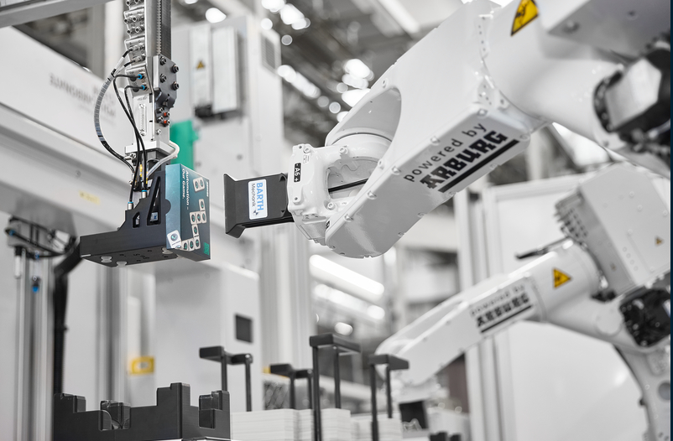

An autonomous automation cell with standalone robots can be used e. g. for pre-assembly tasks.

rControl mobile control panels _M1A1317

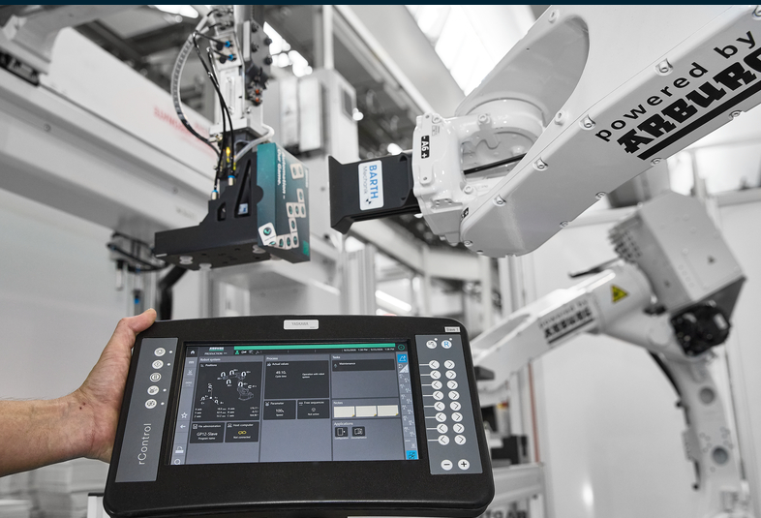

To enable the robots in the standalone version to be programmed and operated independently, they are fitted with a new mobile control panel that can be operated intuitively.

Photos: ARBURG
Photo download:
https://media.arburg.com/web/8879b2fa6e0a9cdc/standalone-robots-fakuma-2026/

Press release
File: ARBURG press release robots Standalone Fakuma 2026_en_GB.docx
Characters: 3,332
Words: 480

You can also download this and other press releases from our website at www.arburg.com/de/presse/ (www.arburg.com/en/presse/)

Contact
ARBURG GmbH + Co KG
Press Office
Susanne Palm
Dr Bettina Keck
PO Box 1109
72286 Lossburg
Tel.: +49 7446 33-3463
Tel.: +49 7446 33-3259
presse_service@ARBURG.com

About ARBURG
Founded in 1923, this German family-owned company is one of the world’s leading manufacturers of injection moulding machines. The ARBURG family also includes AMKmotion, a manufacturer of electric drive systems.
Arburg’s portfolio for plastics processing comprises Allrounder injection moulding machines, robotic systems and customer- and industry-specific turnkey solutions. It also includes digital products and services. Within the plastics industry, Arburg is a pioneer in the areas of energy and production efficiency, digitalisation and sustainability. Arburg machines are used to manufacture plastic products for industries such as Mobility, Packaging, Electronics, Medical, Construction and equipment engineering, and Leisure.
The company’s headquarters are in Lossburg, Germany. Furthermore, ARBURG has its own organisations in 27 countries at 37 locations and, together with its distribution partners, has representation in over 100 countries. Of the total workforce of around 3,300 employees, approximately 2,7 are based in Germany and around 600 work in ARBURG’s organisations worldwide.
ARBURG is certified to ISO 9001 (quality), ISO 14001 (environment), ISO 27001 (information security), ISO 29993 (training) and ISO 50001 (energy).
Further information: www.arburg.com, www.amk-motion.com.

